SV Team | SV | May 11, 2017

SV Deep Dive Training

TDM Training notes

Contents

**TDM Introduction** 2

**Sample Workflow** 2

**1.** **Data Profiling** 3

**2.** **Data Sub setting** 29

**3.** **Data Masking** 51

**4.** **Synthetic Data Generation** 62

**5.** **Agile Requirements Designer** 76

**6.** **Useful Links** 82

# **TDM Introduction**

CA TDM: CA Test Data Manager uniquely combines elements of data sub setting, masking and synthetic, on-demand data generation to enable testing teams to meet the agile needs of the organization

* TDM is used to Build test data warehouse from production environment
* It takes data from database, creates repository, masks, profiles, provide data from ‘Data management’ data base
* From Production it takes ‘Gold Copy’ data and creates own ‘DATA MART’ and gives tester the required data
* This Data Mart is done by test engineers, who takes data for tester using TDM and Tester in team uses the data provided by test engineers

**Sample Workflow**

Test engineers takes corresponding data, for ex: Order management from TD warehouse and move it to oracle db.

Gold Copy (Production env)

Test Data Warehouse (all data)

Oracle db. of order management etc.

From here Tester takes data for testing

1. **Data Profiling**

It helps to understand the nature of the data and overall data model. It helps to take data from legacy db. Data Maker is the app used.

Login Screen

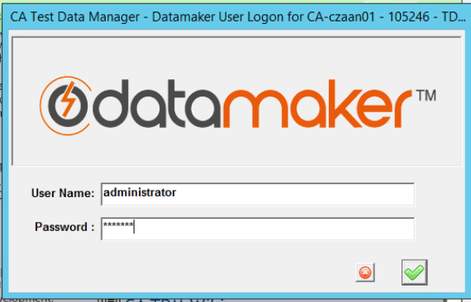

Create or Select the Source and Target DB and Select Green icon on the bottom left corner ‘Connect to databases and startup’ icon

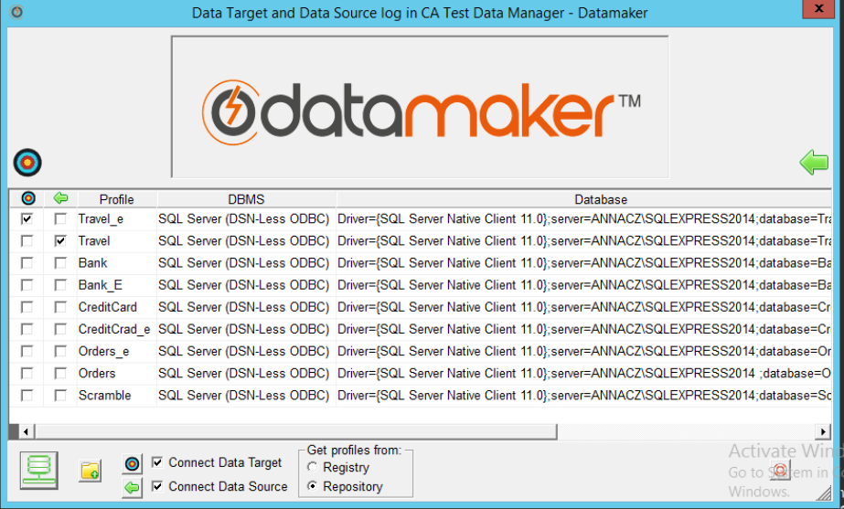

Select Projects from menu & select Project Manager option

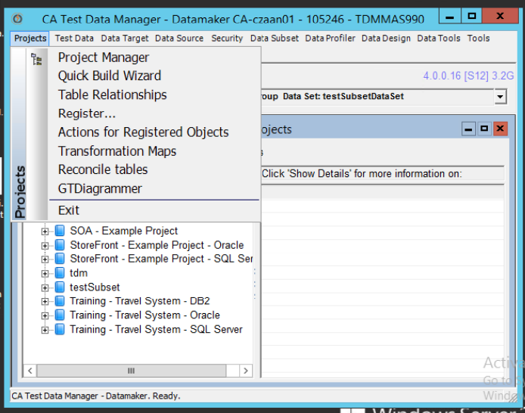

Right click on project and select New Project and Version

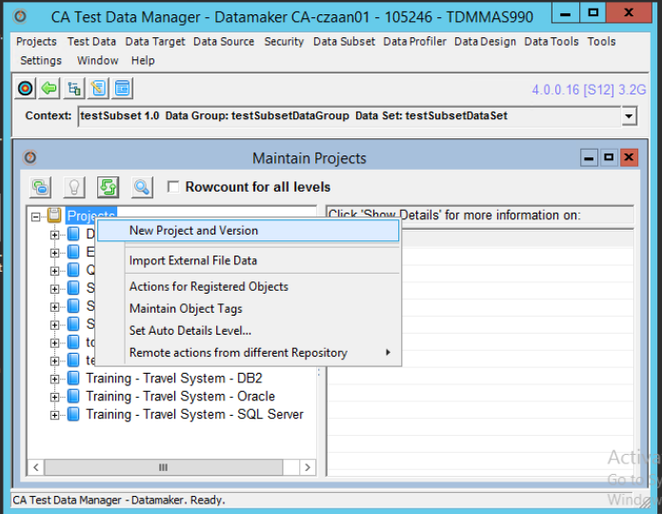

Enter below required details and click Save button.

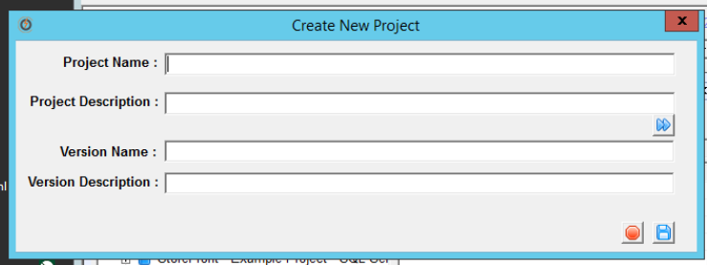

Select the newly created version number under newly created Project in above step, and select New Data Group option

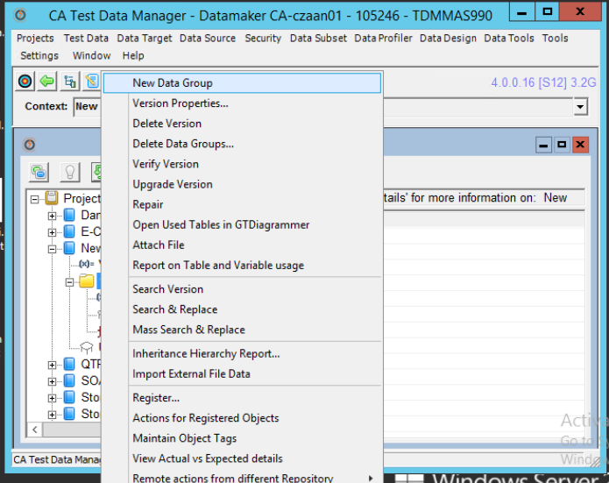

Similarly create create new datagroup, new dataset and new data pool subsequently

Create New Data Group screeen

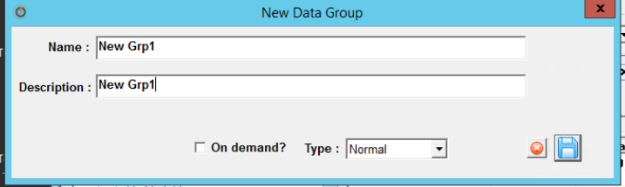

Create New Data Set screeen

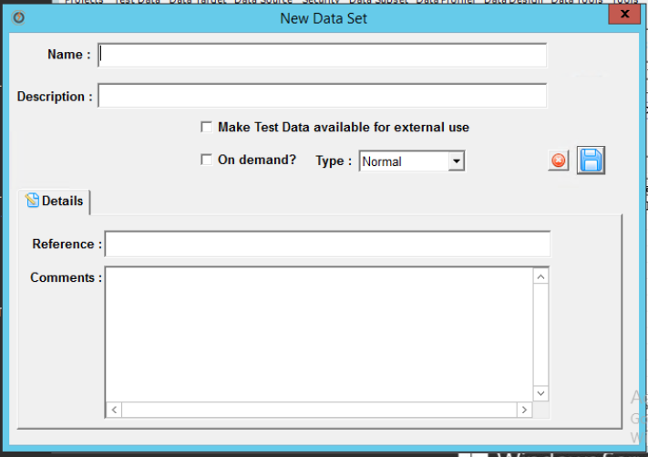

Create New Data Pool screen

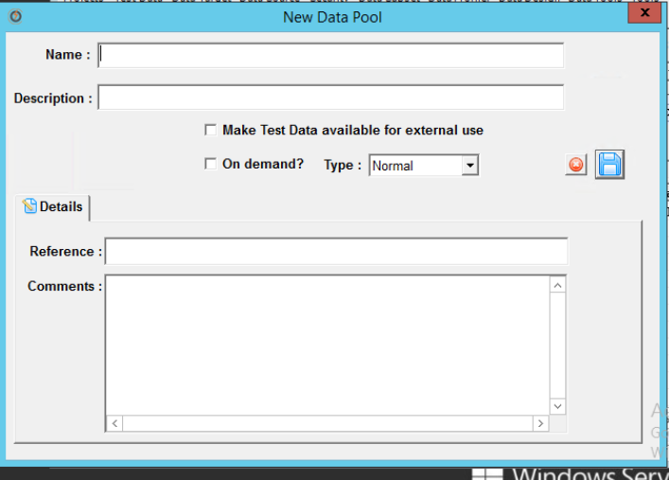

New Project > New Data group > New Dataset > New Data pool

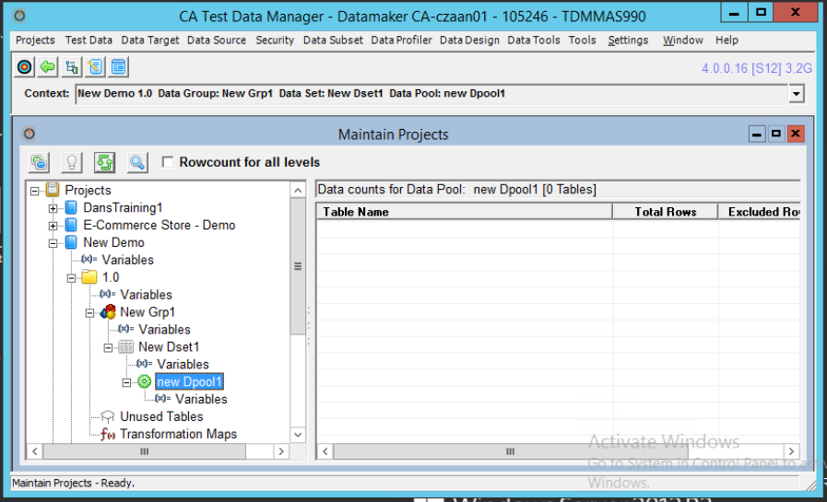

Click on version of the newly creted project and select Register from drop down list to register tables from the DB

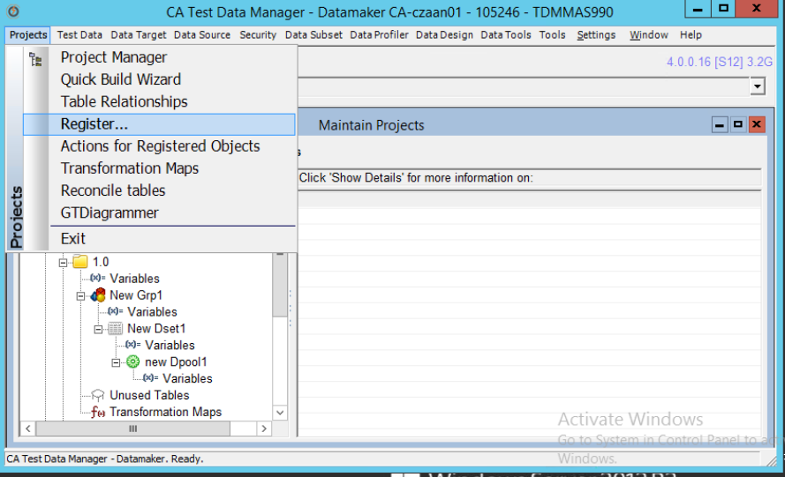

Select the Green Button

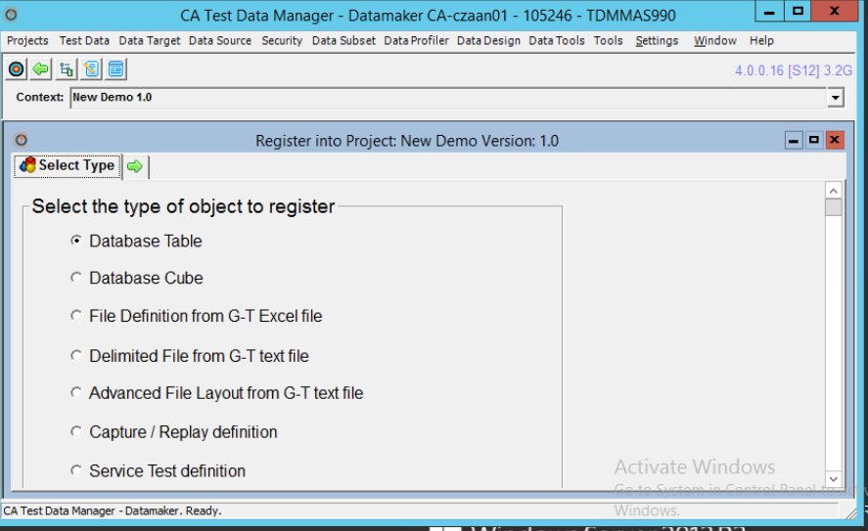

Select **Register Tables from Data Source** from drop down list & Select all the tables and run (Green Button)

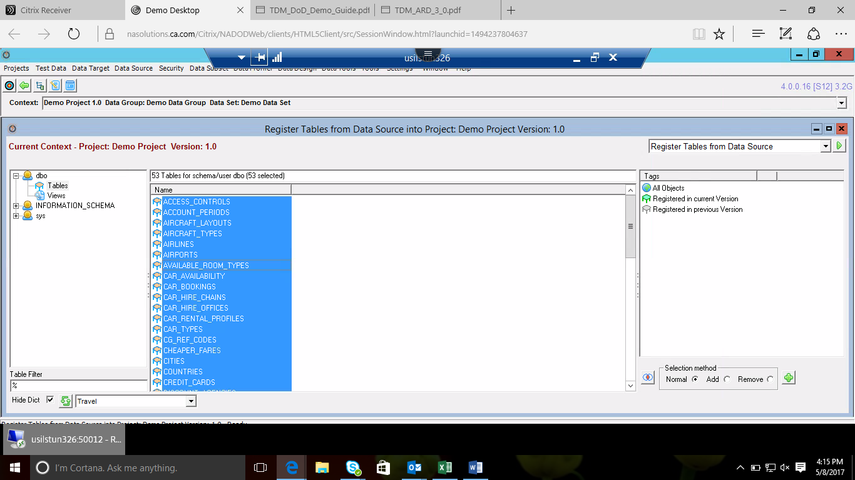

Registering tables

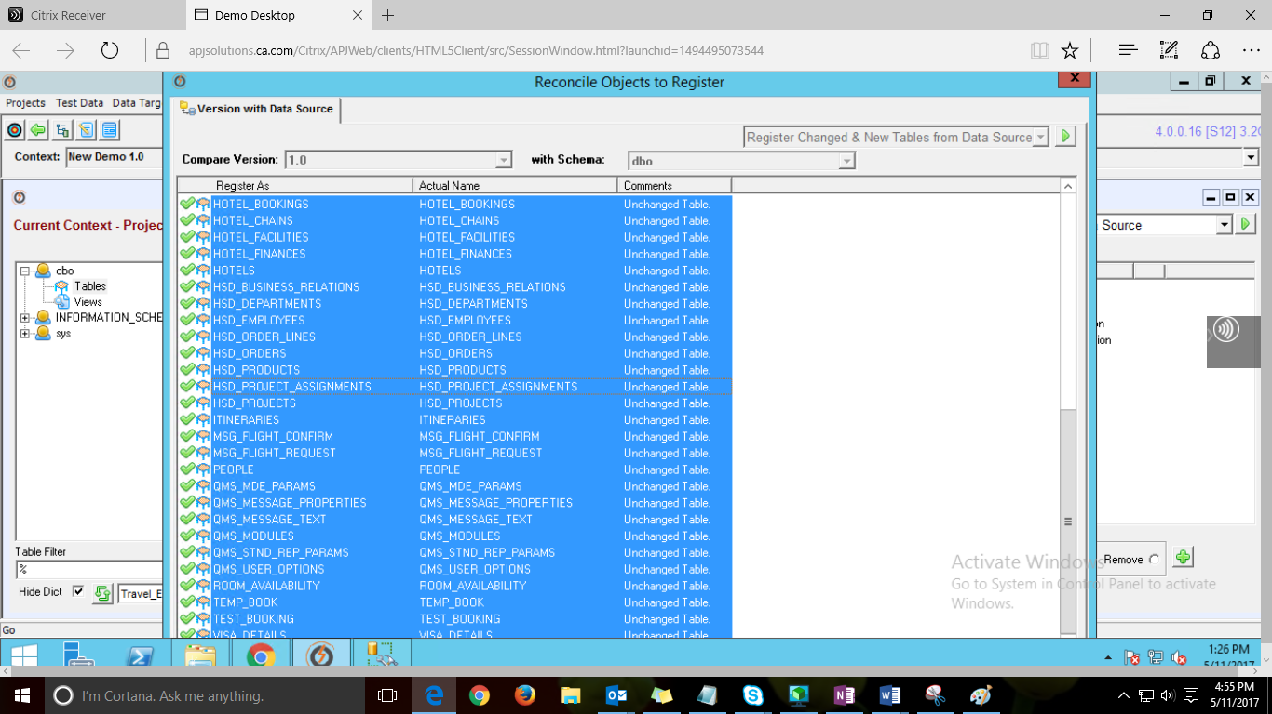

Tables are successfully registered

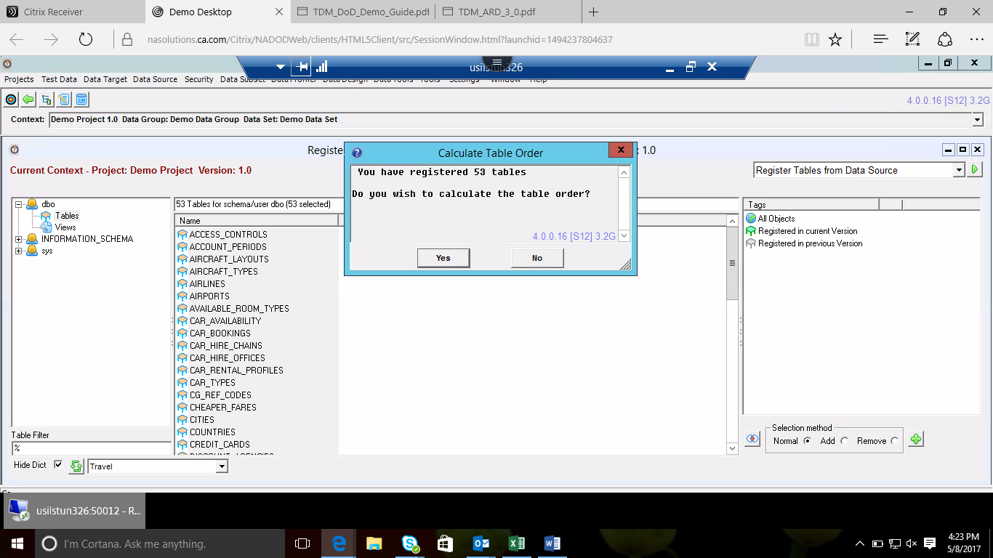

Select Projects > Actions for Registered Objects

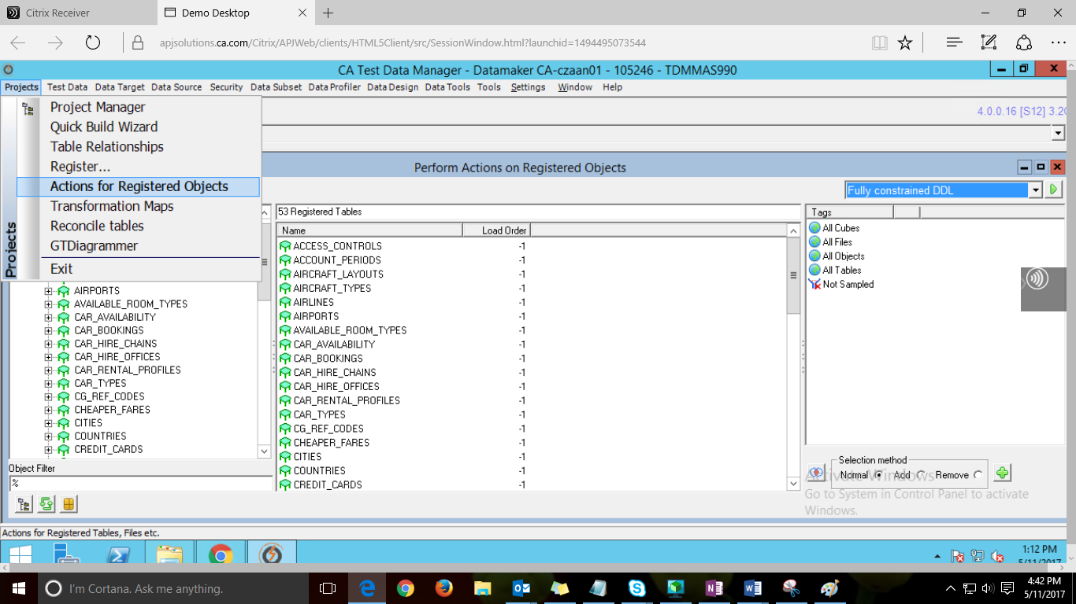

Select all the tables and select **Open Tables in GTDiagrammer** from drop down list and select Run

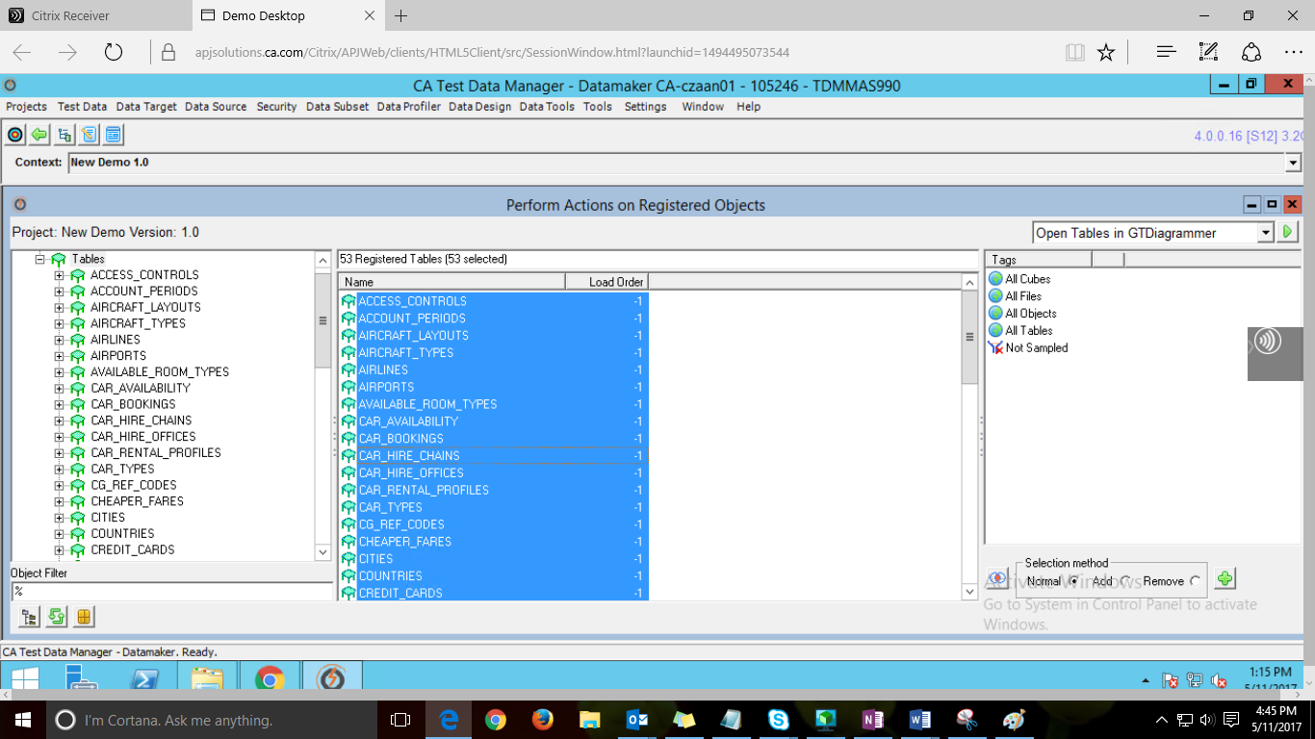

GTDiagrammer window, Save the file if required

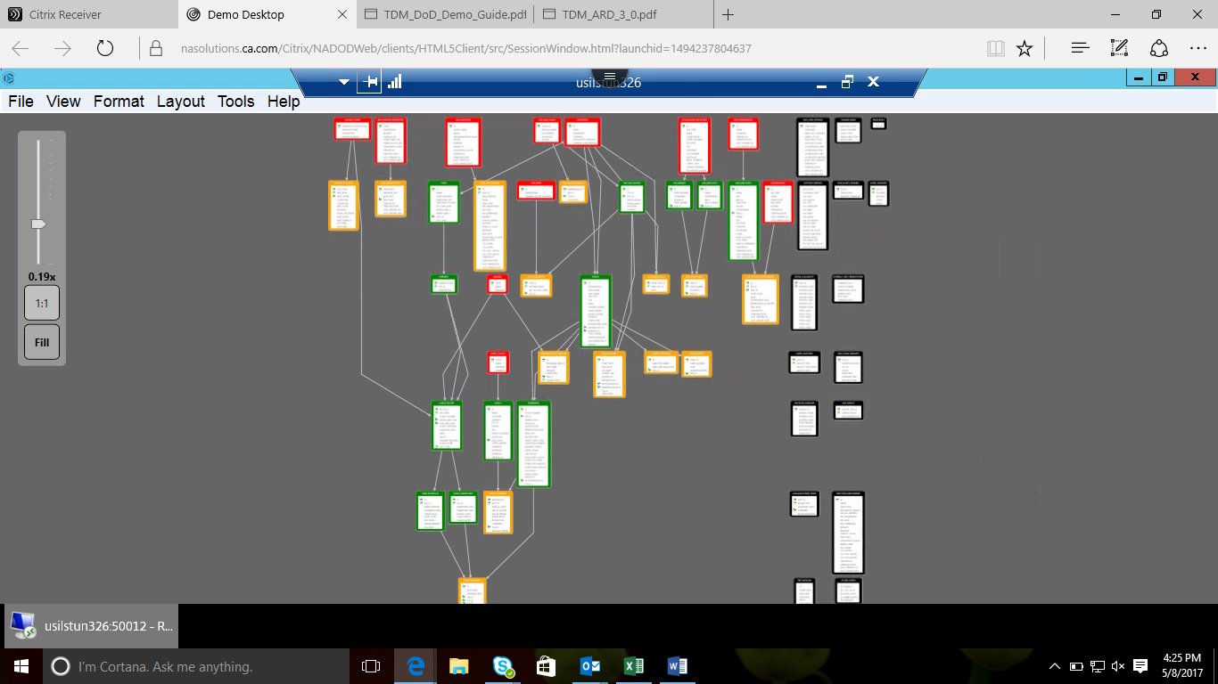

**Data Profiling: Examining the content of data**

Go to Data profile from the menu and then select Sample Table Data option

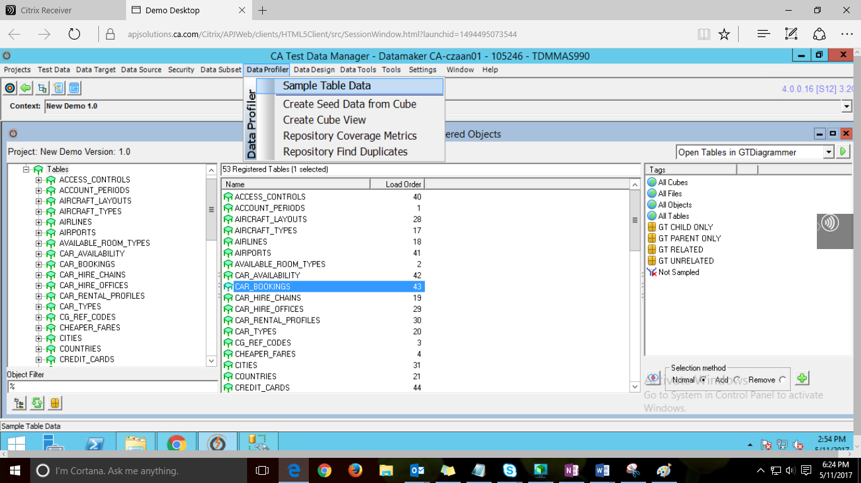

Select all tables and select **Sample Data** from the drop down and run.

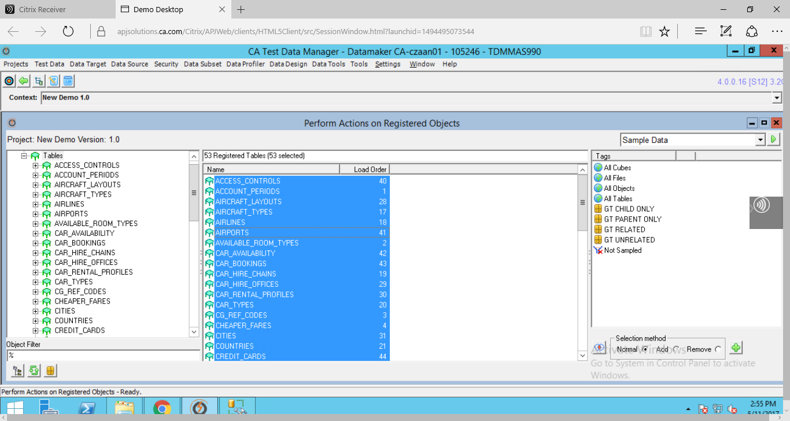

Click on Build and Save button at the bottom

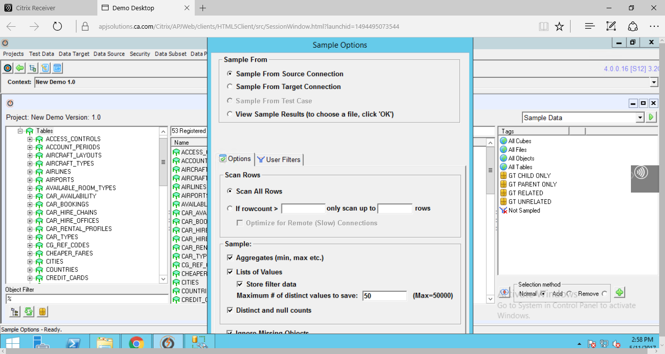

Data Sampling is in process

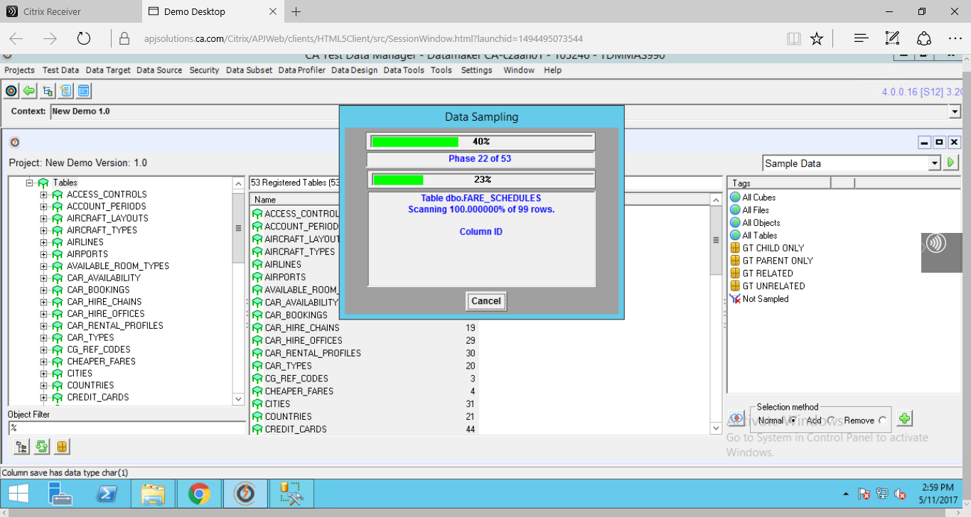

Select all the Colum Names by clicking on the Save column name and click Save button in the corner of the page

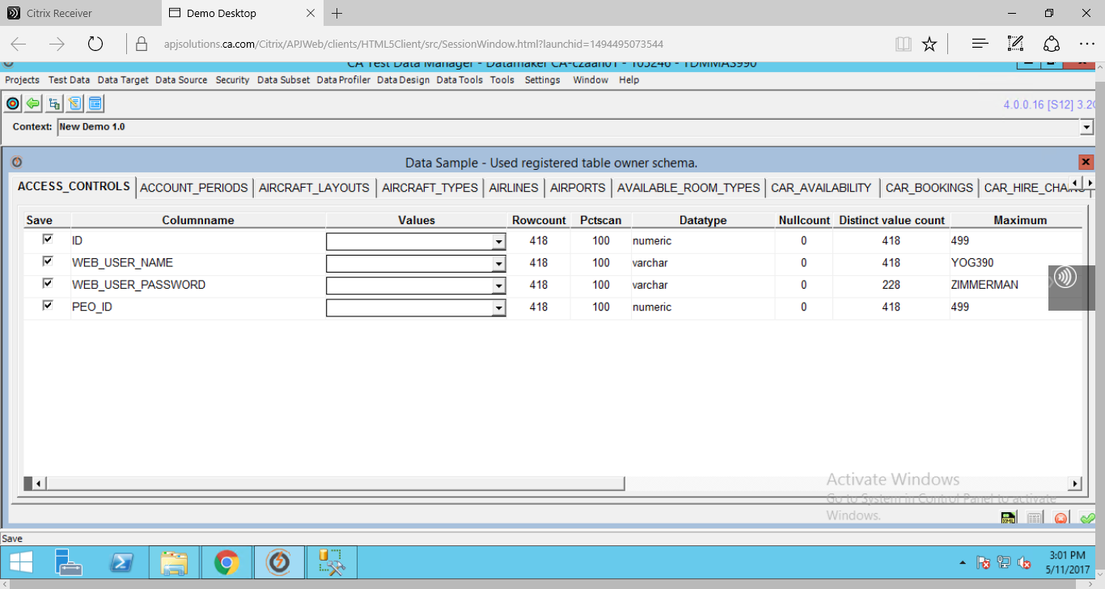

Click Save in Choose Sample Type window

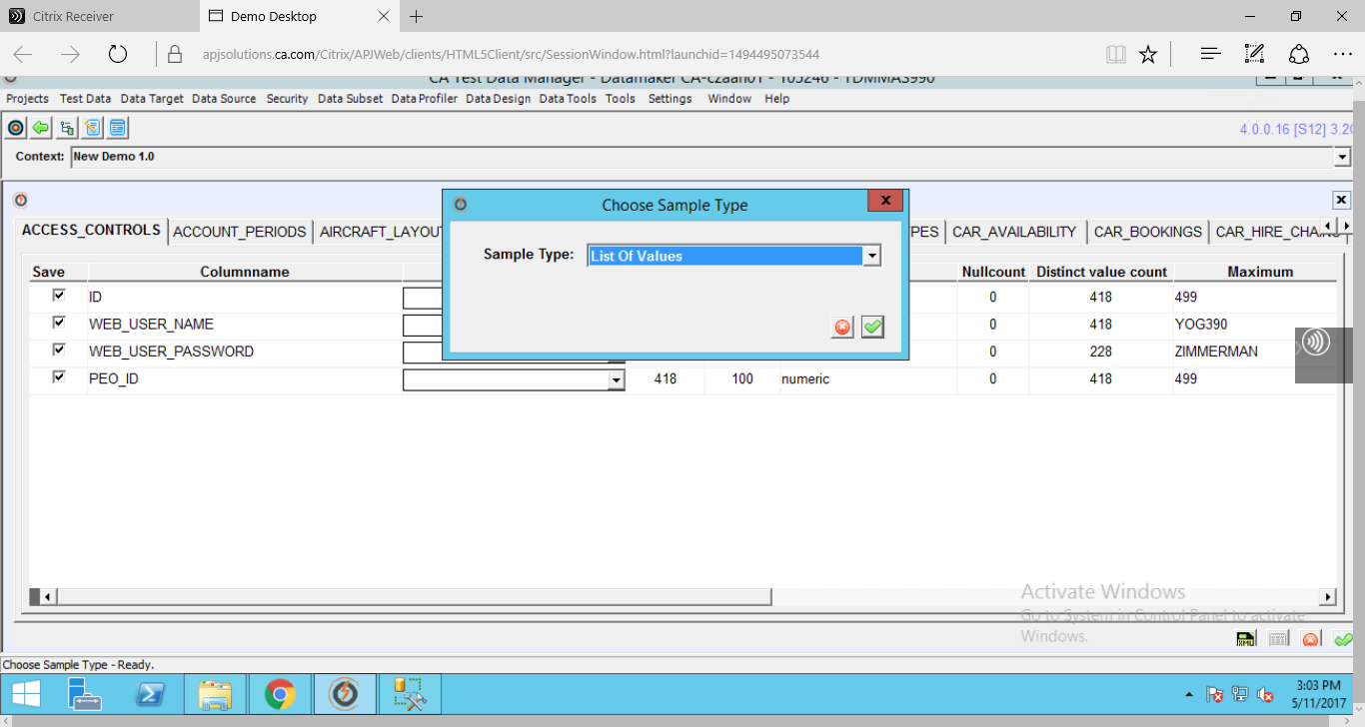

Click Save button in Sample Column Values window

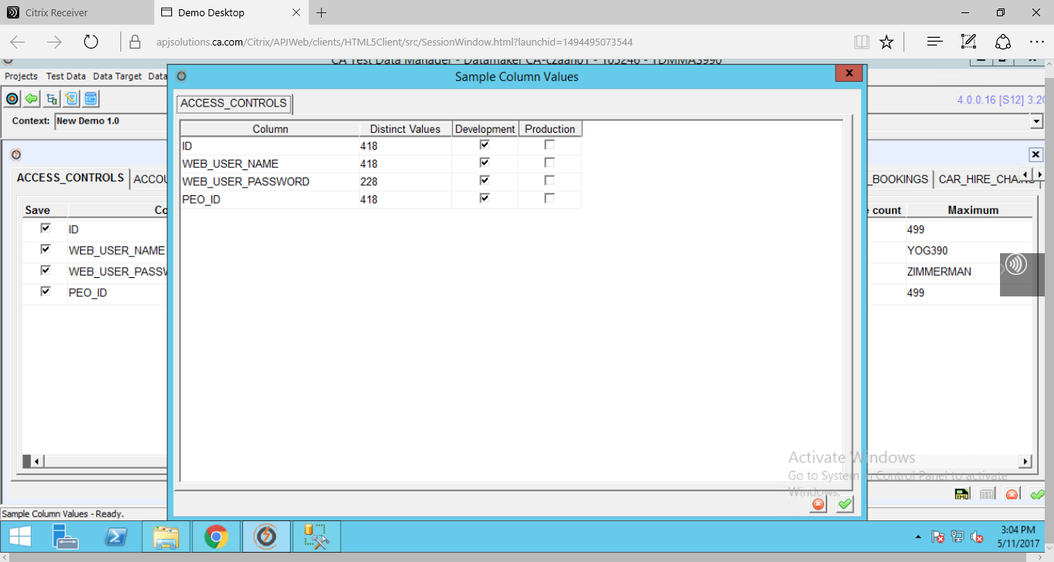

Data Sample window

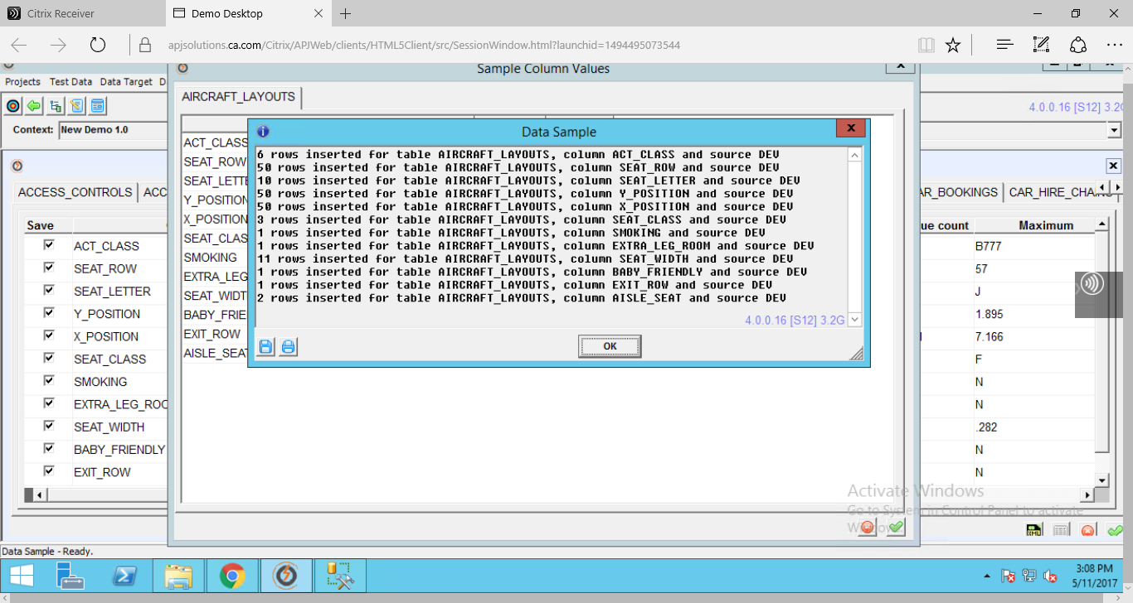

Generate Reports if required

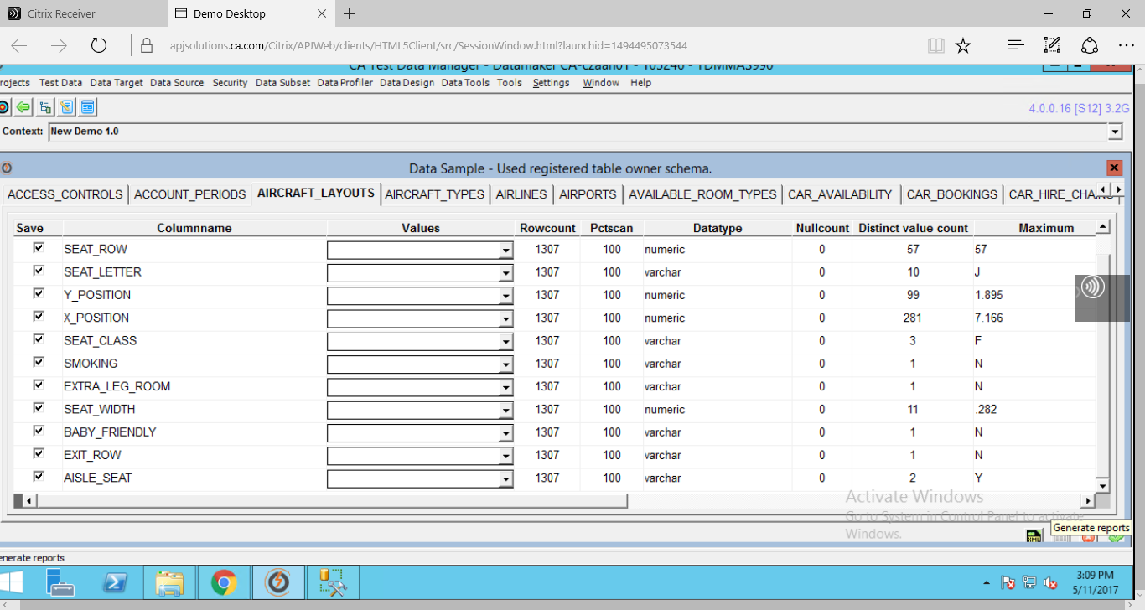

Reports are generated

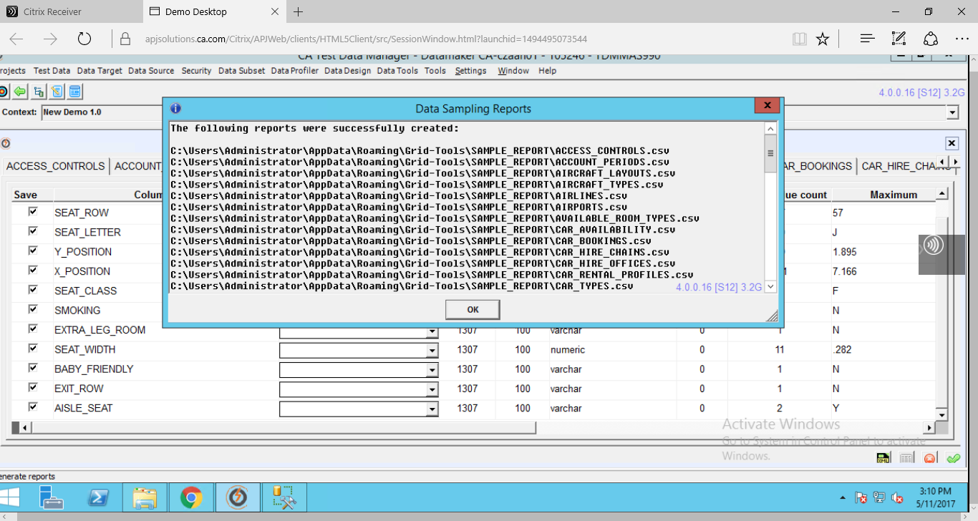

1. **Data Sub setting**

Cloning of specific subsets of data into target environments are done here. **DATASUBSET** app is used.

Pre Requisite:

1. Make sure that you are connected to Data Source and Data target
2. Create a Project with Data group, Data pool and Data set

In GT DataMaker click on the **Target button**

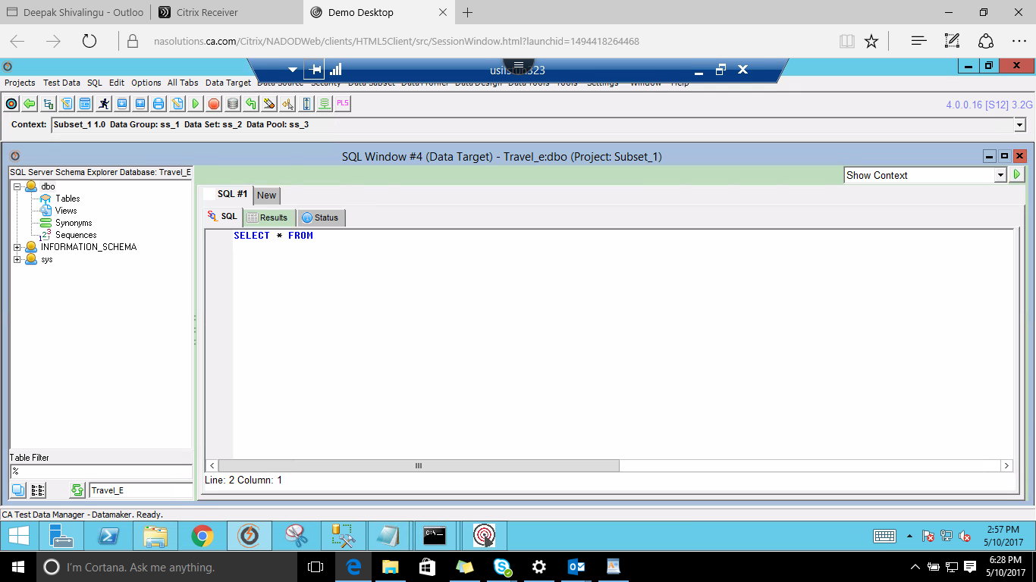

Right Click on Tables and select the option **Copy a set of 'TRUNCATE' statements for the table** option

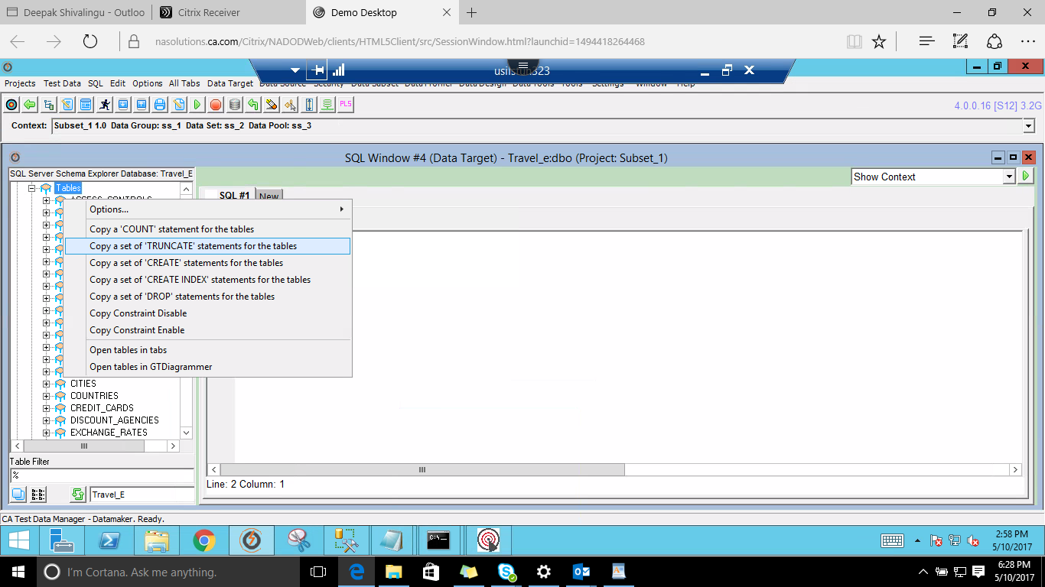

Paste the copied statements and run by using **Alt+A** key

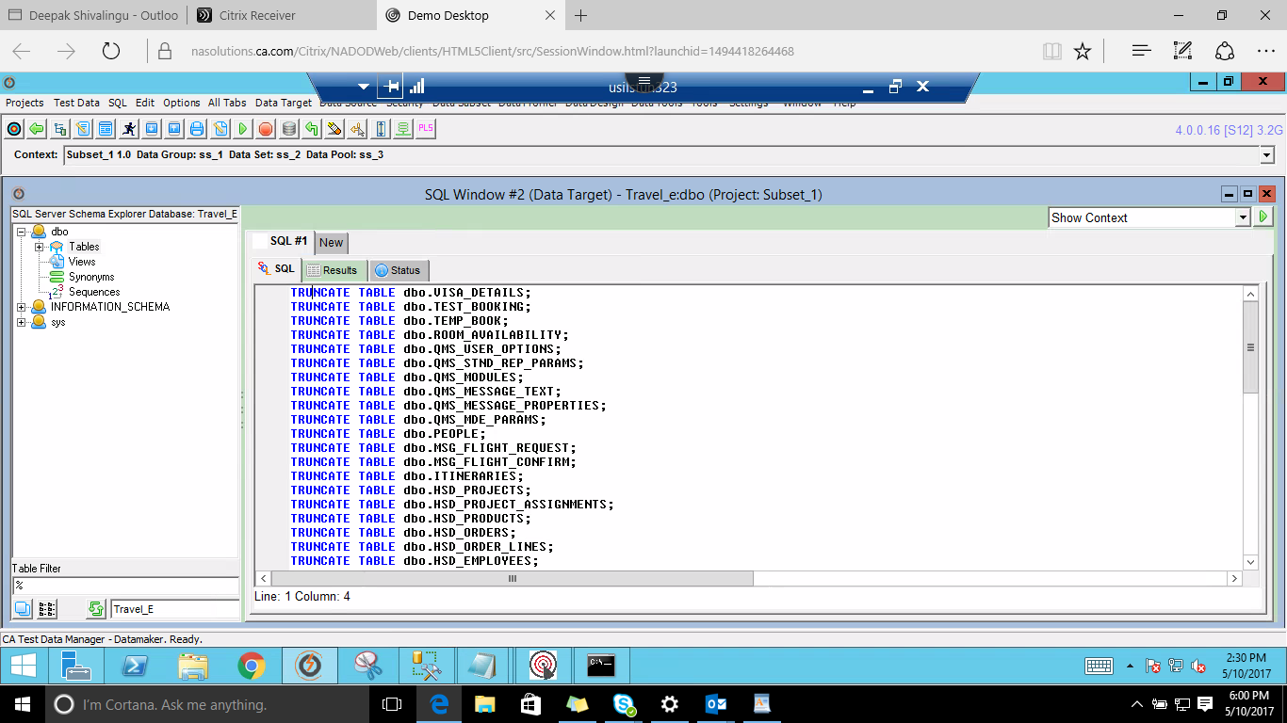

This is to ensure that there is empty database space

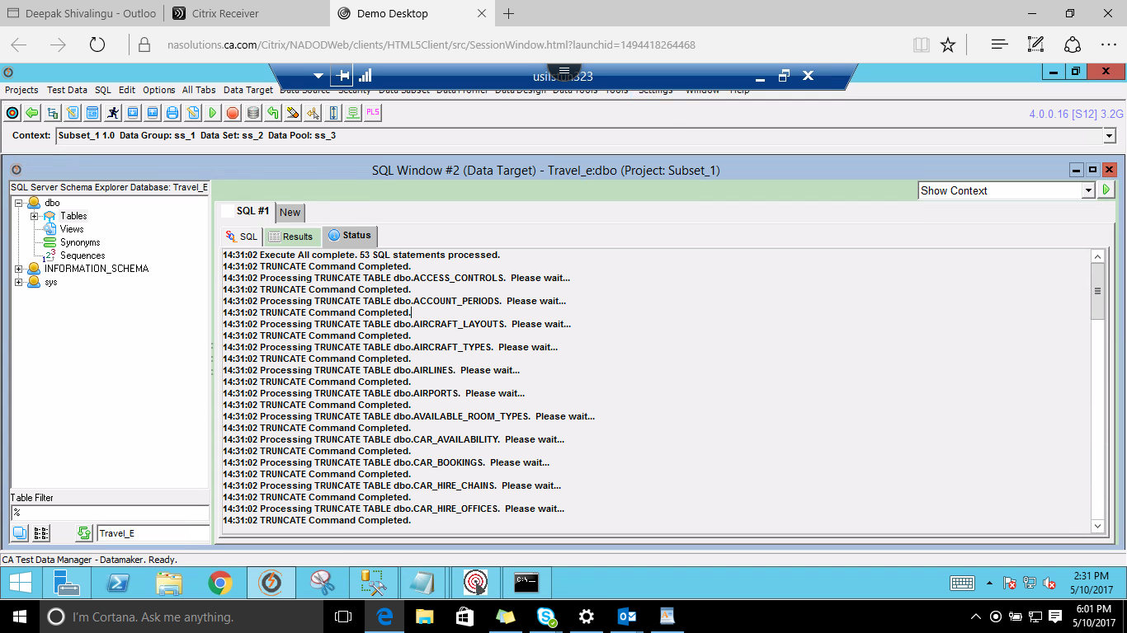

**Launch GT SUBSET app**

Select available connection to login or create new profile by providing below required details

[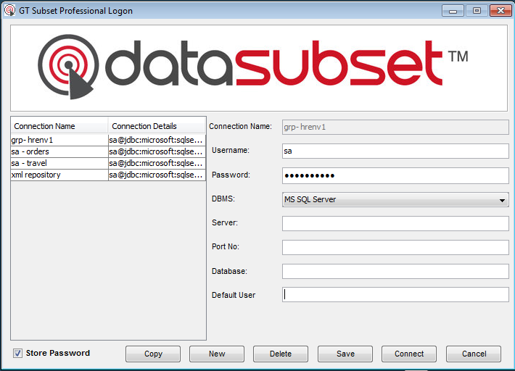](https://www.google.co.in/url?sa=i&rct=j&q=&esrc=s&source=images&cd=&cad=rja&uact=8&ved=0ahUKEwj91MbczOnTAhWCVBoKHS5FChIQjRwIBw&url=https://www.ca.com/us/services-support/ca-support/ca-support-online/knowledge-base-articles.tec1596344.html&psig=AFQjCNE02XTNqjkGW8ZzKUcWG5LXRNXQAA&ust=1494652529316658)

* Select Utilities > Connect Repository
* Select the suitable repository or create a New Profile
* Fill all the details and make sure the connection has access to Repository tables else below error message will display

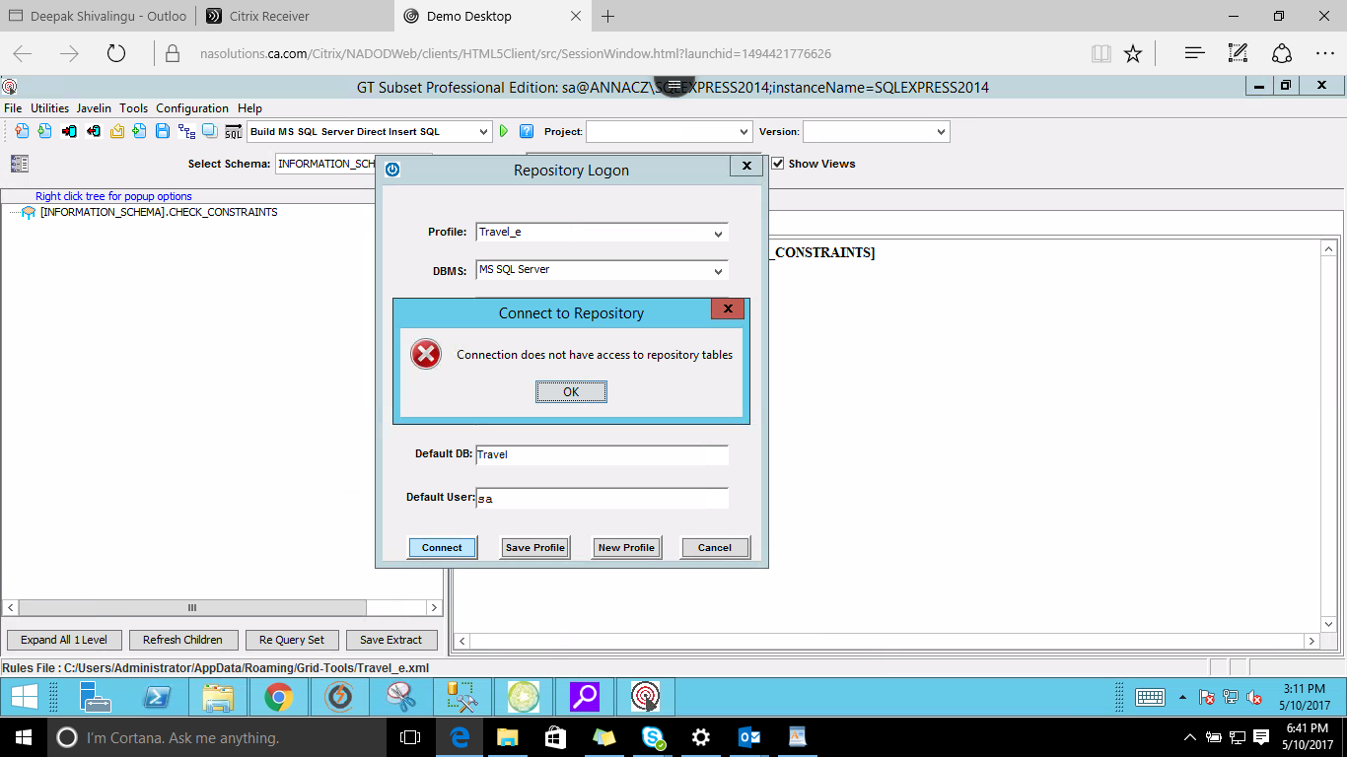

Either select already existing profile from drop down list

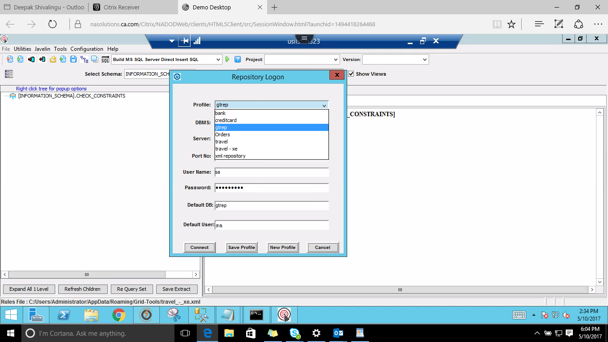

Else fill the details in the Repository Logon window & Click Connect button

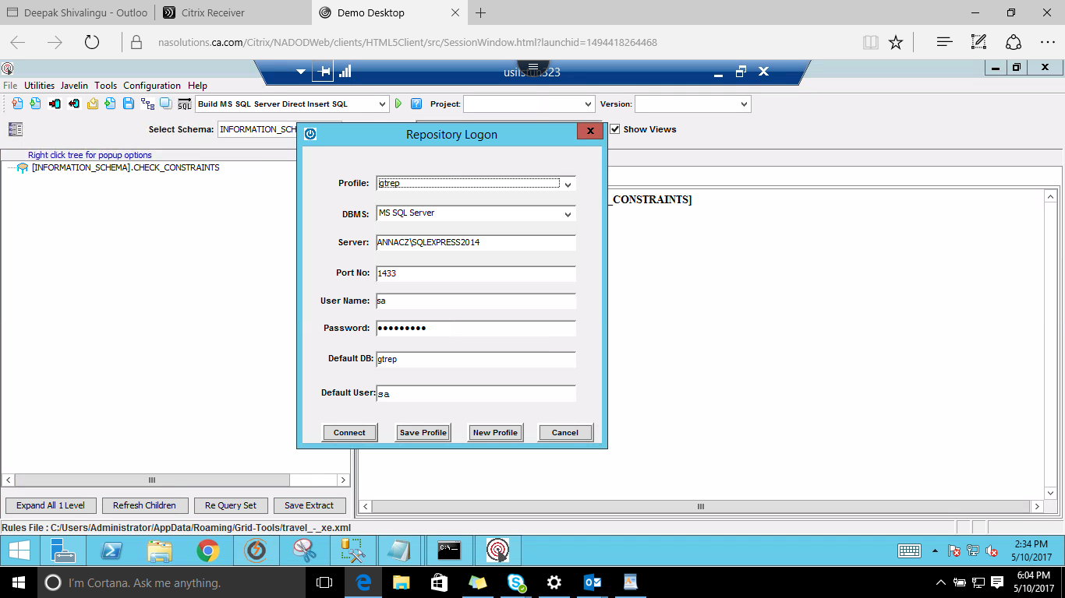

Make sure you save this extract to a Repository by navigating to File > Save Extract to Repository option

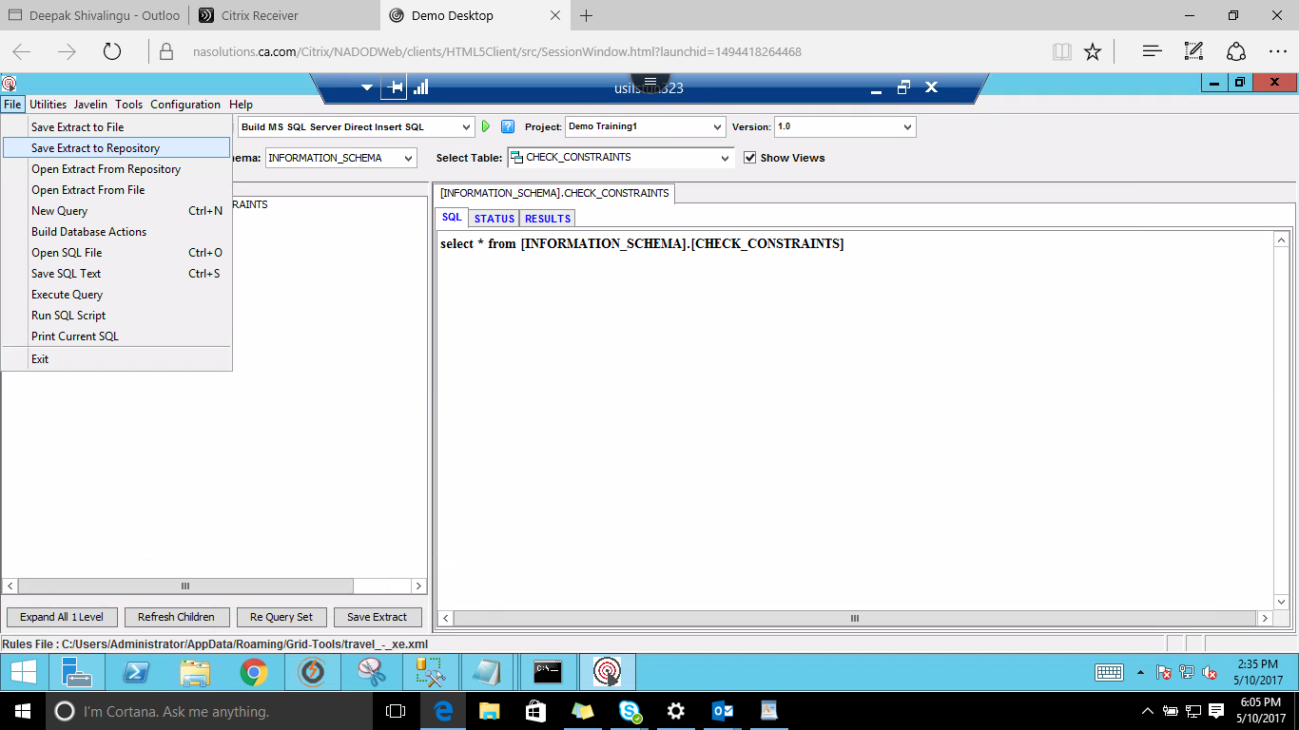

Fill the details and click Save button

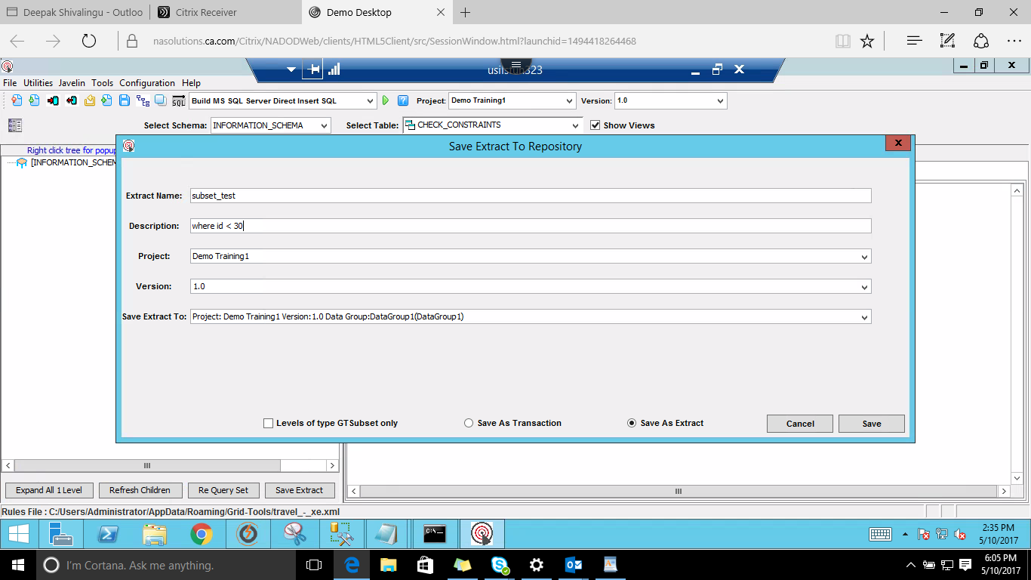

Extract Saved

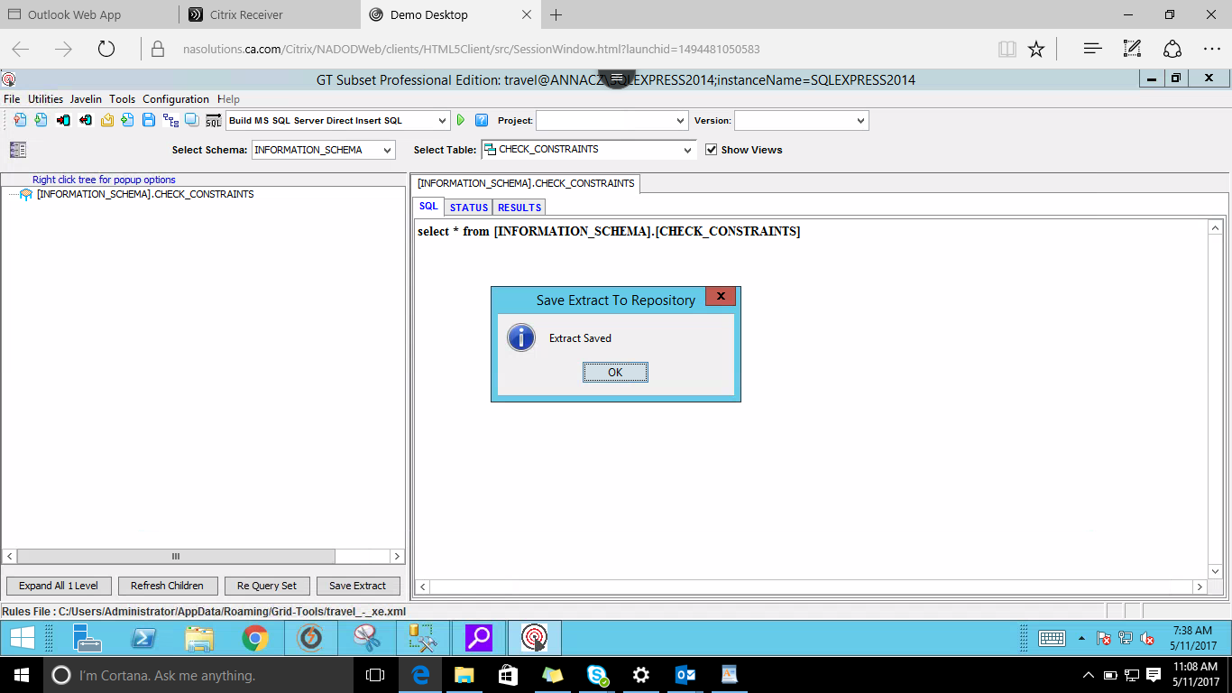

Select Build MS SQL server from Export/Import option from drop down list

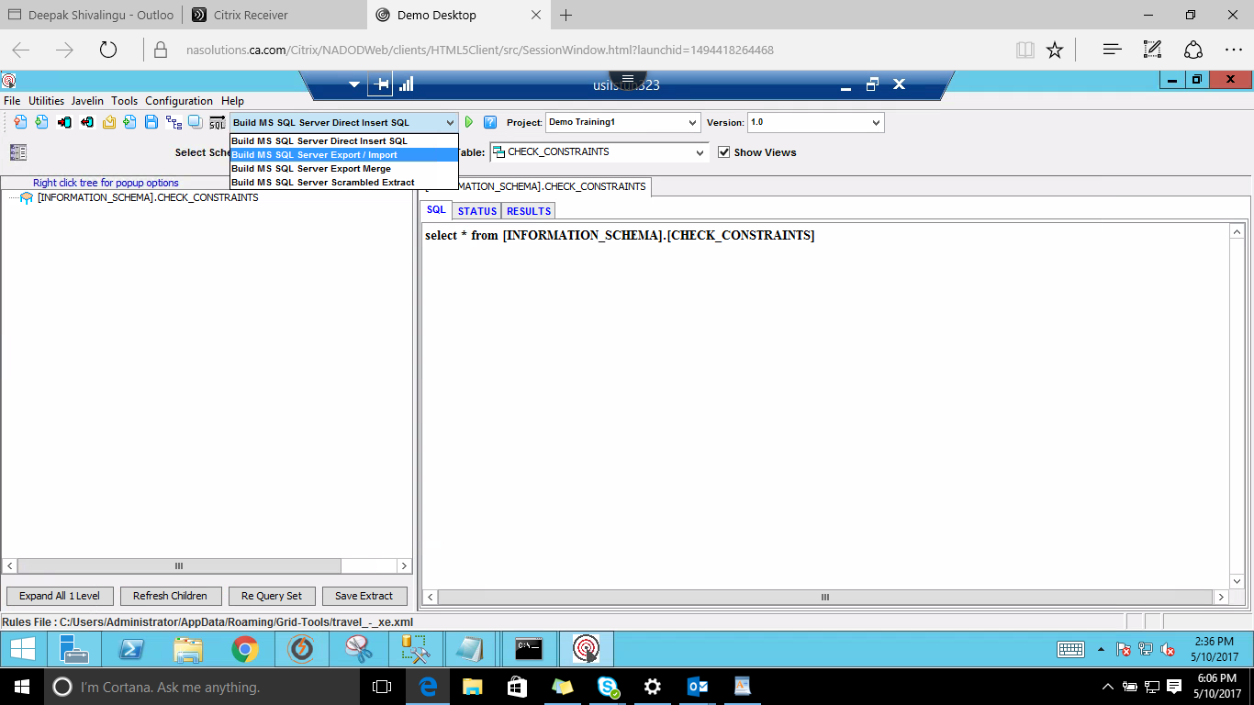

Select Project > Project name from the drop down list (project created as per pre-requisite)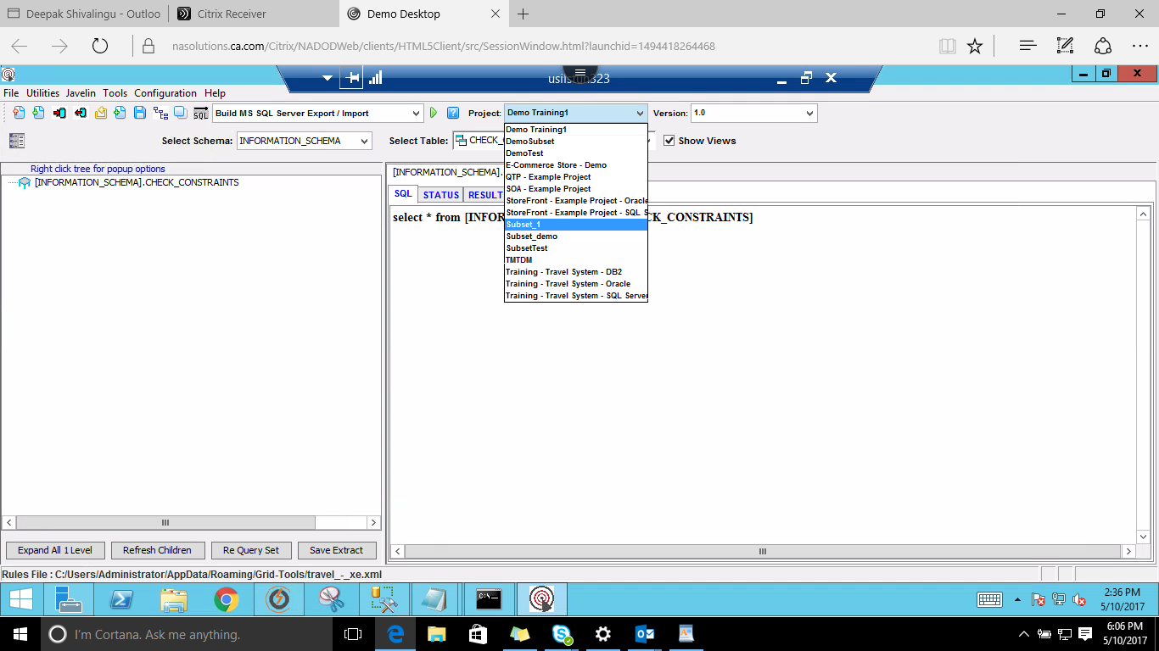

Select Schema > dbo from the drop down list

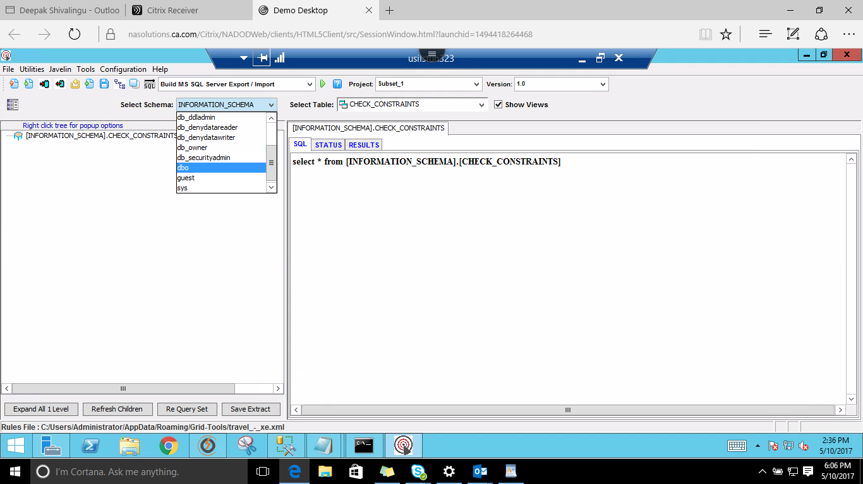

Select the table name from Select Table drop down list

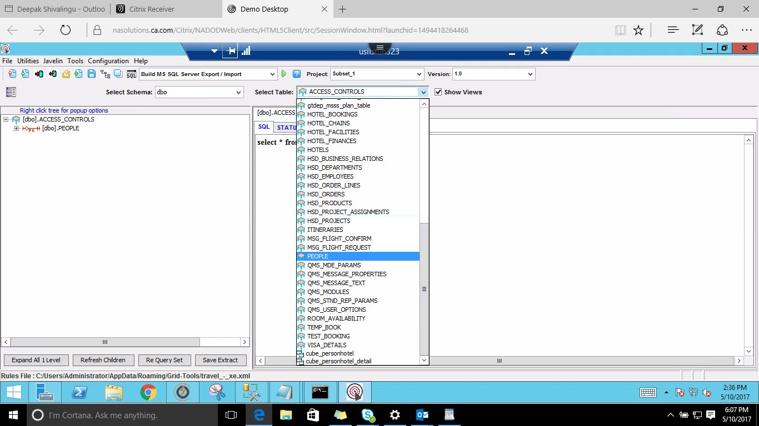

Next Step is to Remove Relationships for managing data hierarchy by, right clicking on PEOPLE’s table > Remove 'Red Relationships' option

This is to maintain a certain hierarchy in the table order

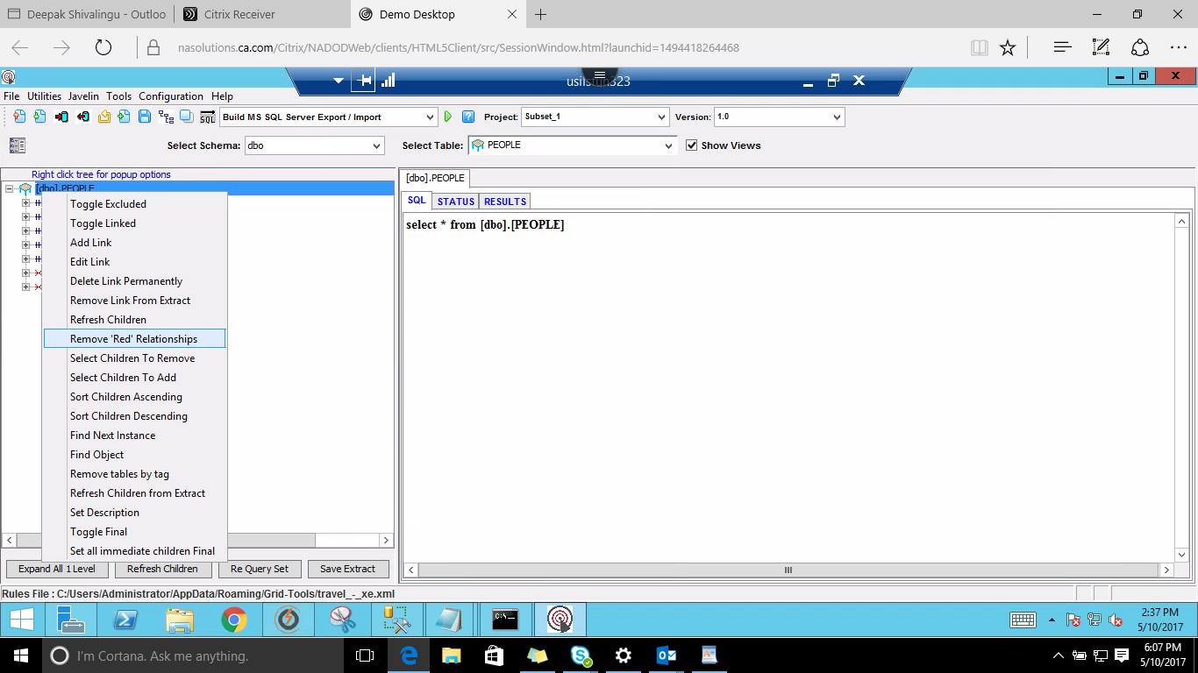

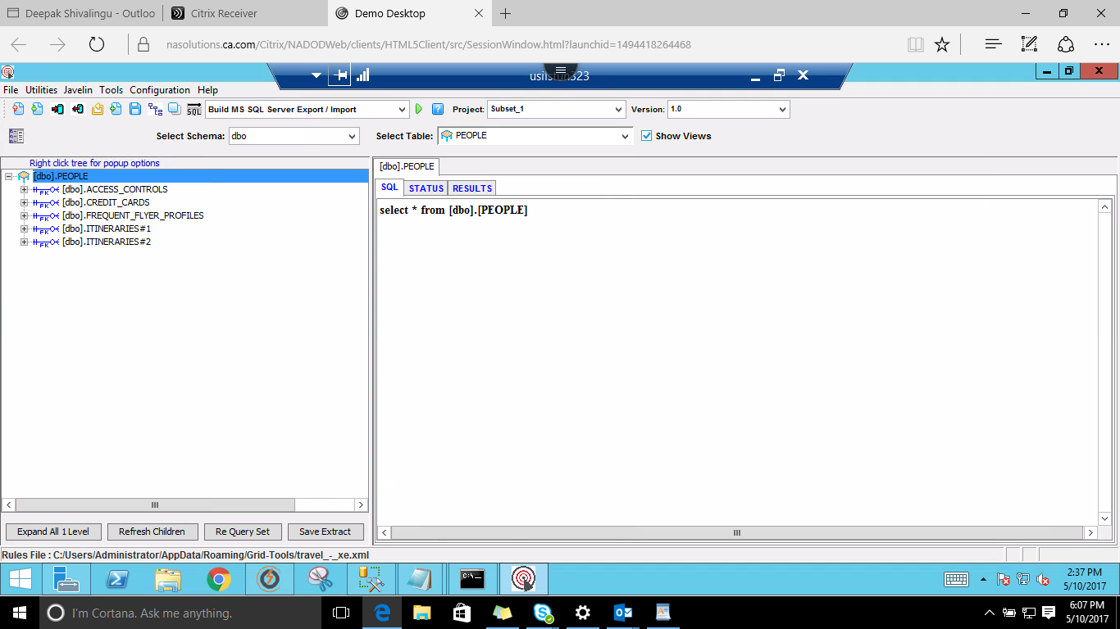

Write an SQL query for the requirements accordingly, here SQL query used is to get ids < 30 from the PEOPLE’s table

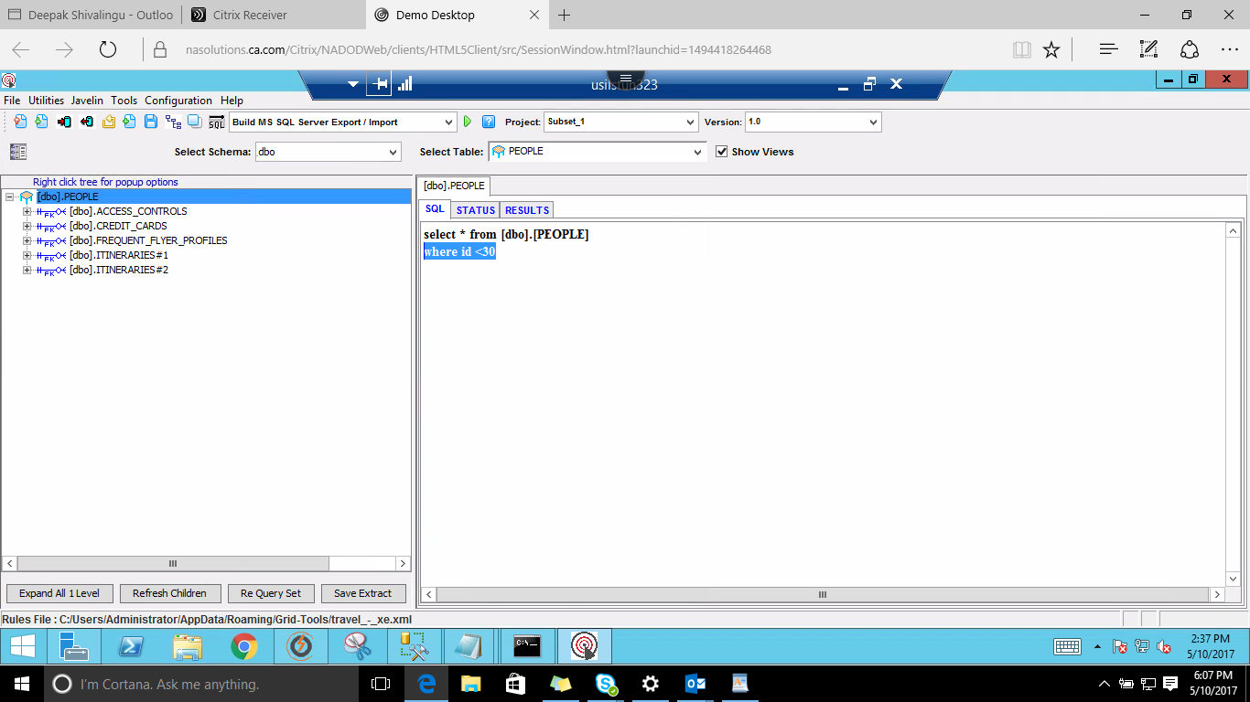

Execute the SQL statement by clicking the Execute SQL button

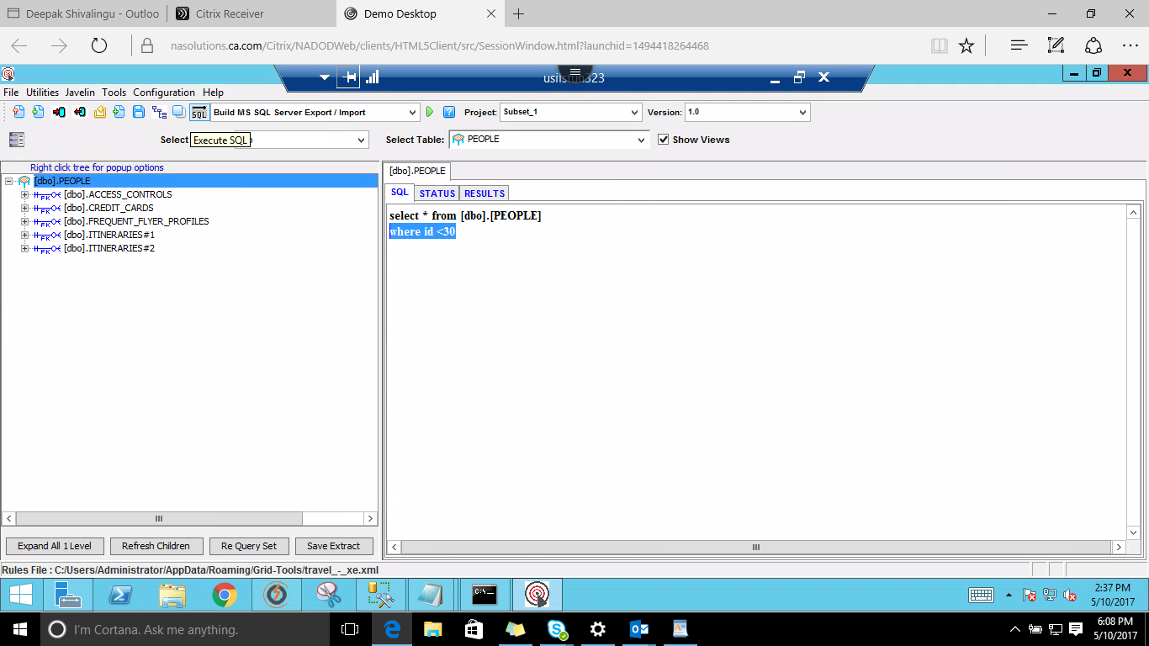

Rows retrieved as a result of the SQL query

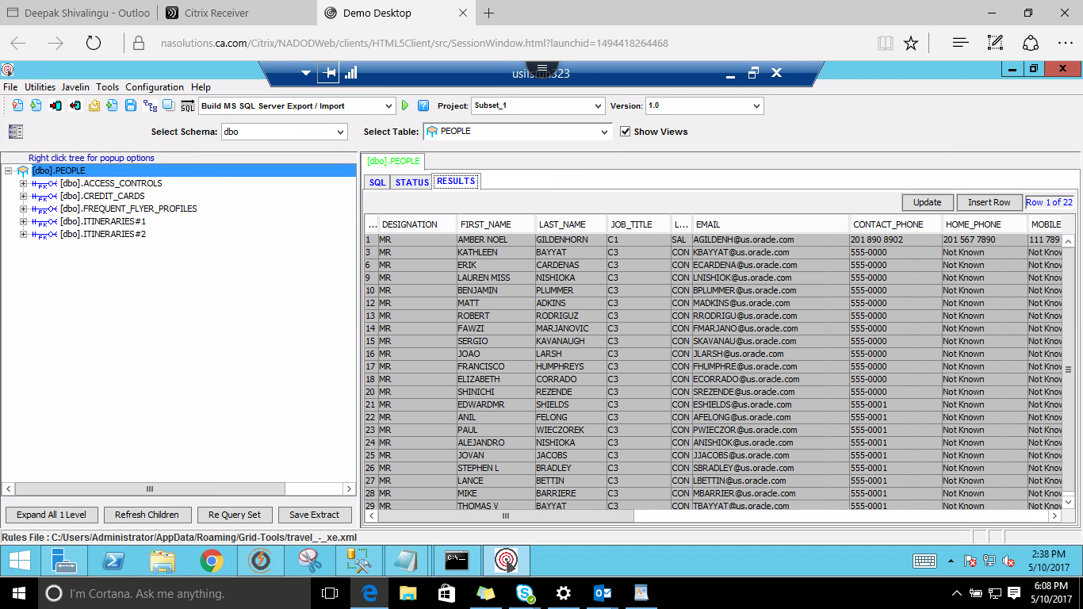

Next click on the Database Actions Button.

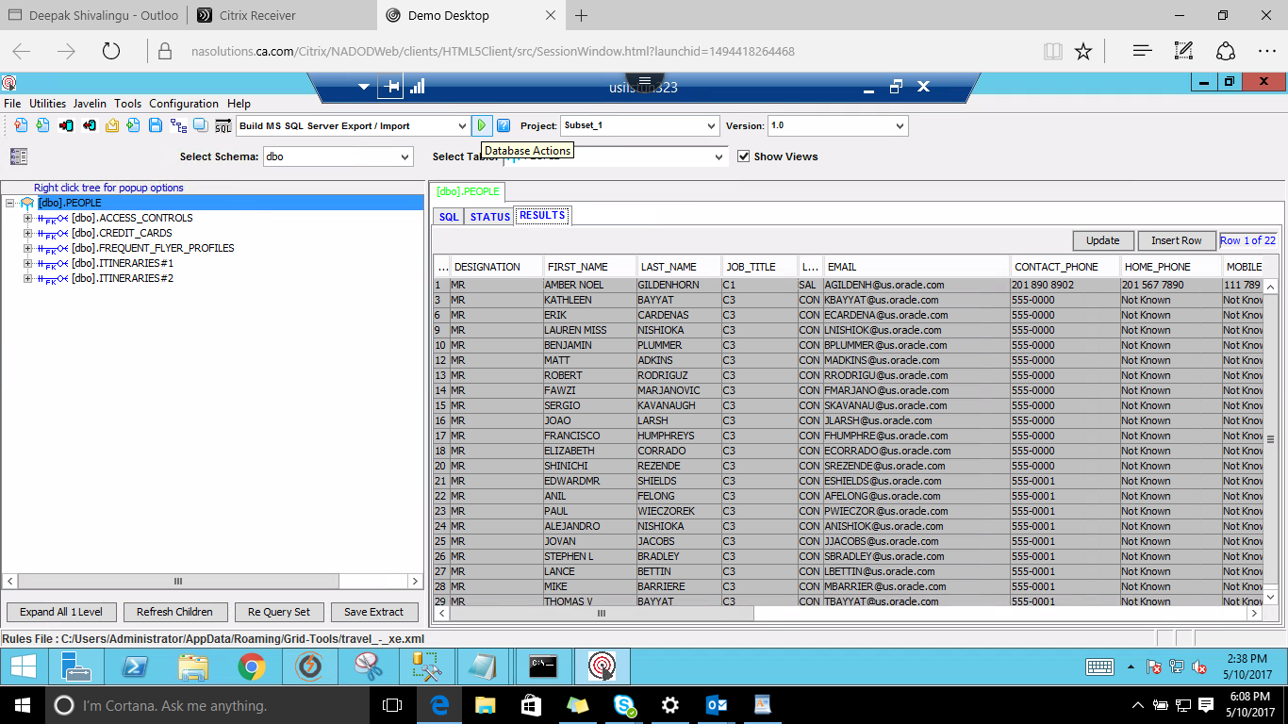

Give Action Name, & navigate to Extract Table tab

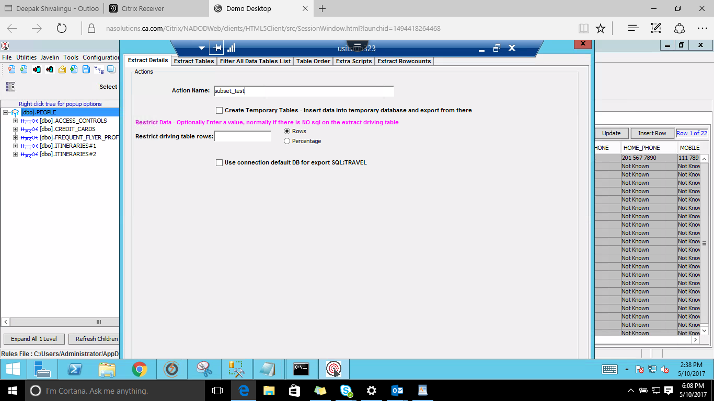The Extract you have saved earlier will be automatically checked in or else select the extract by checking the check box of the saved extract

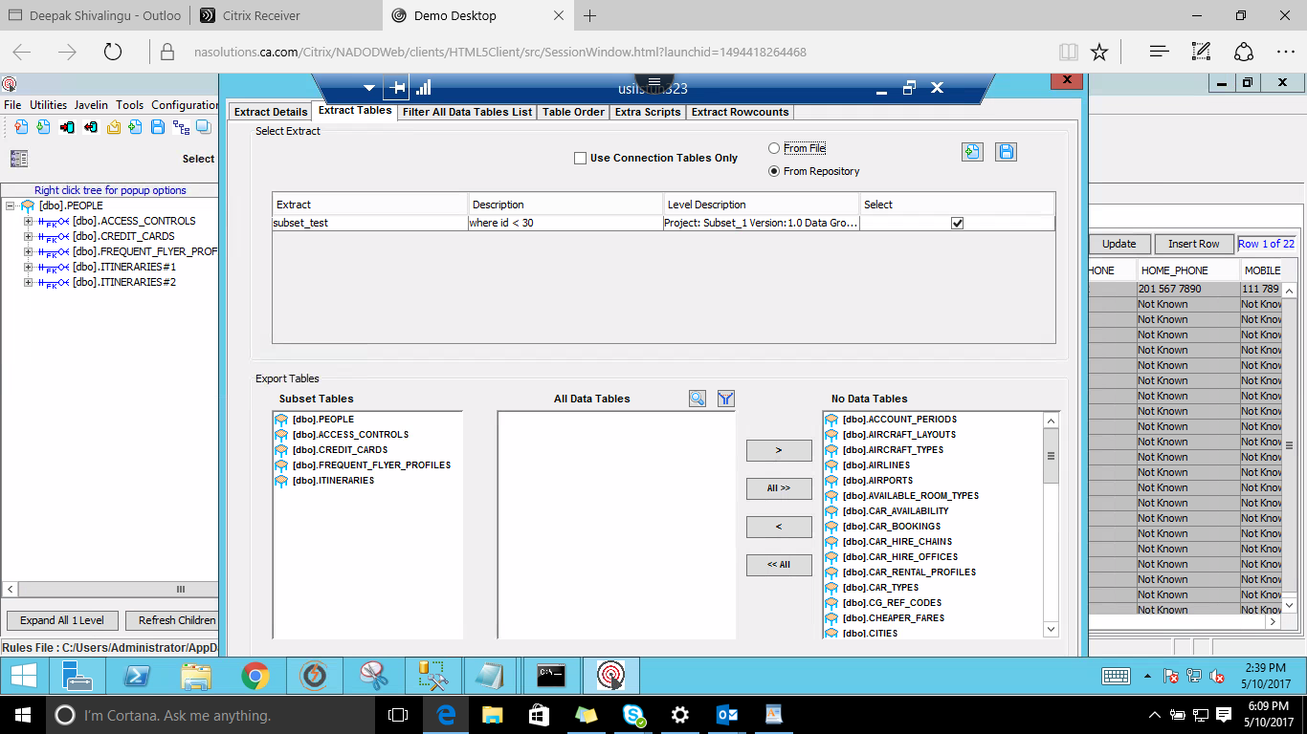

Choose the data tables which are required

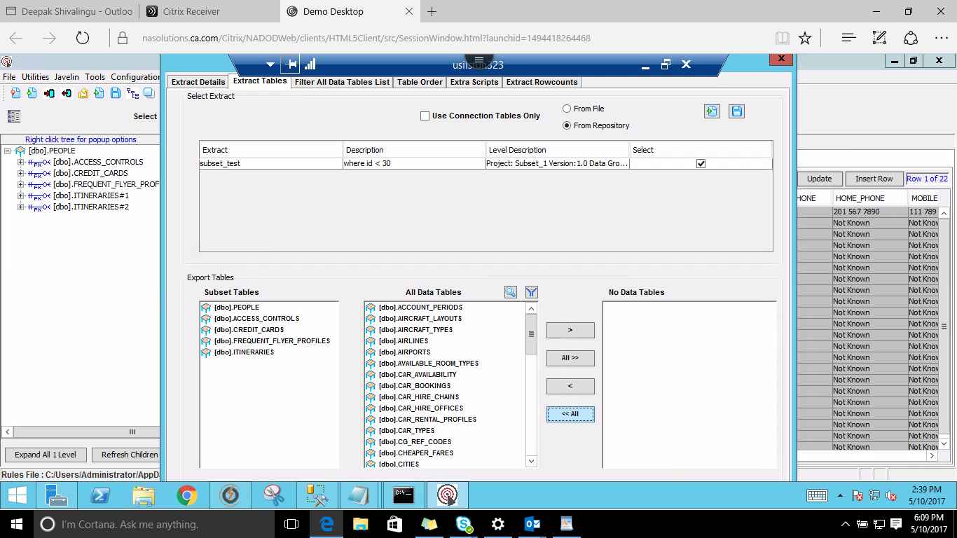

Click on Generate button

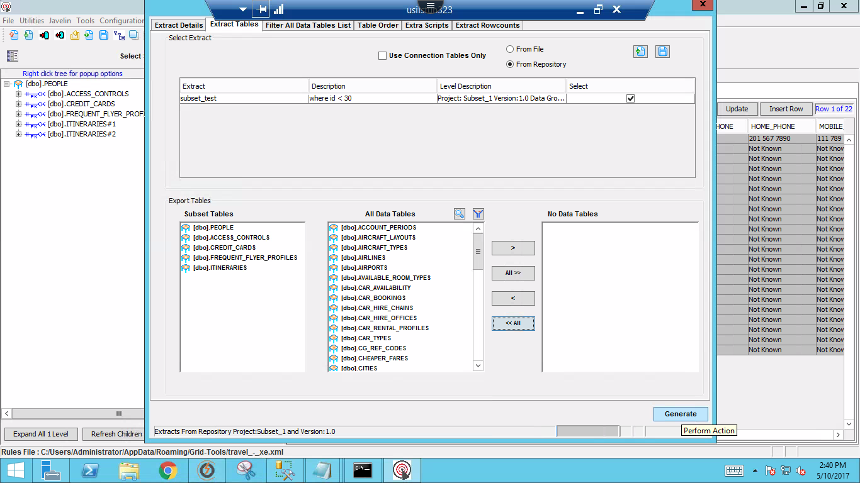

Once you Click on Generate button, the following 3 files will be generated

1. 'Subsetname'_Export.bat
2. 'Subsetname'_import.bat
3. 'Subsetname'_preview.sql

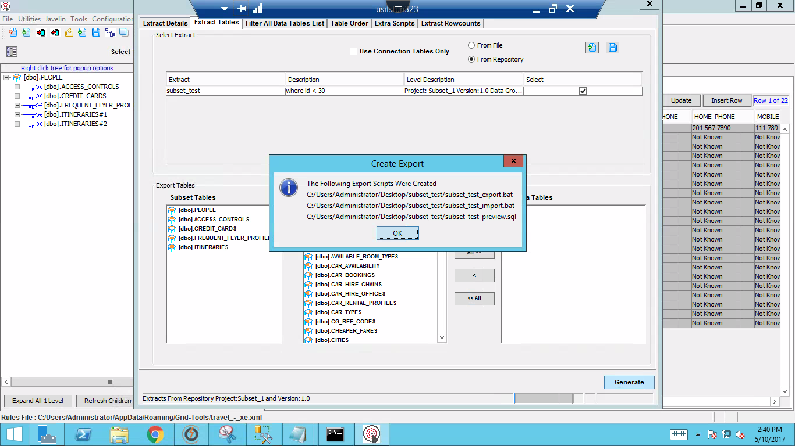

Navigate to the mentioned location

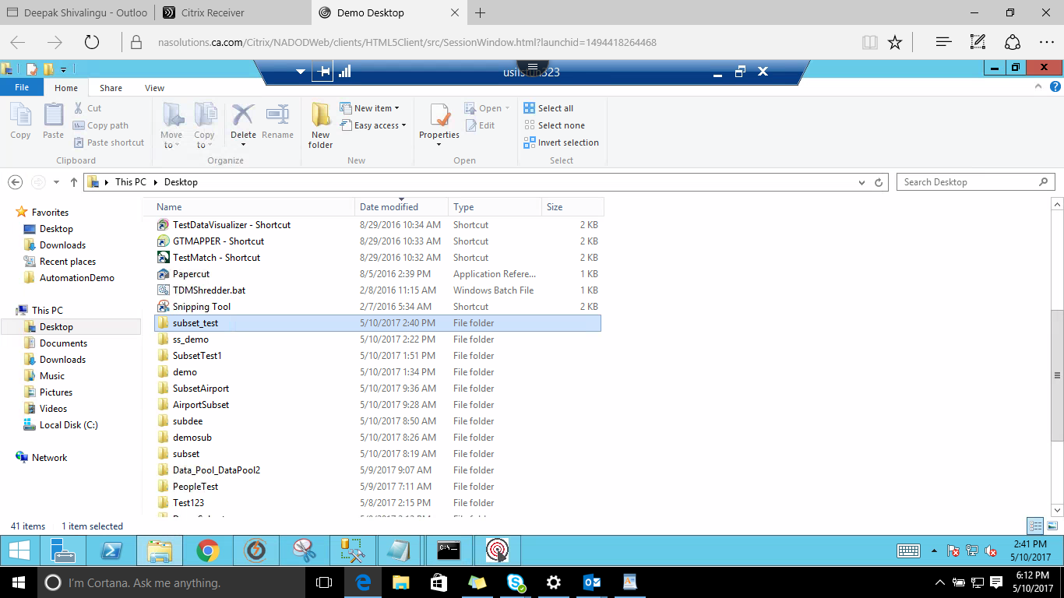

Files are displayed

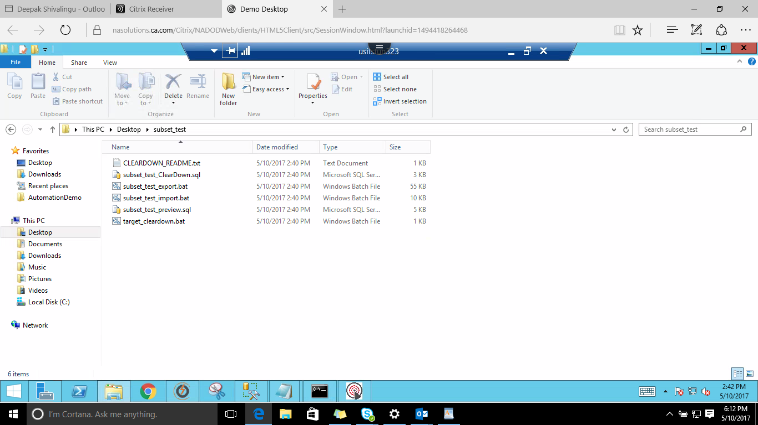

Hold Shift+Right Click Mouse > open the Command Prompt so that the command prompt is in the same directory where the 3 files are

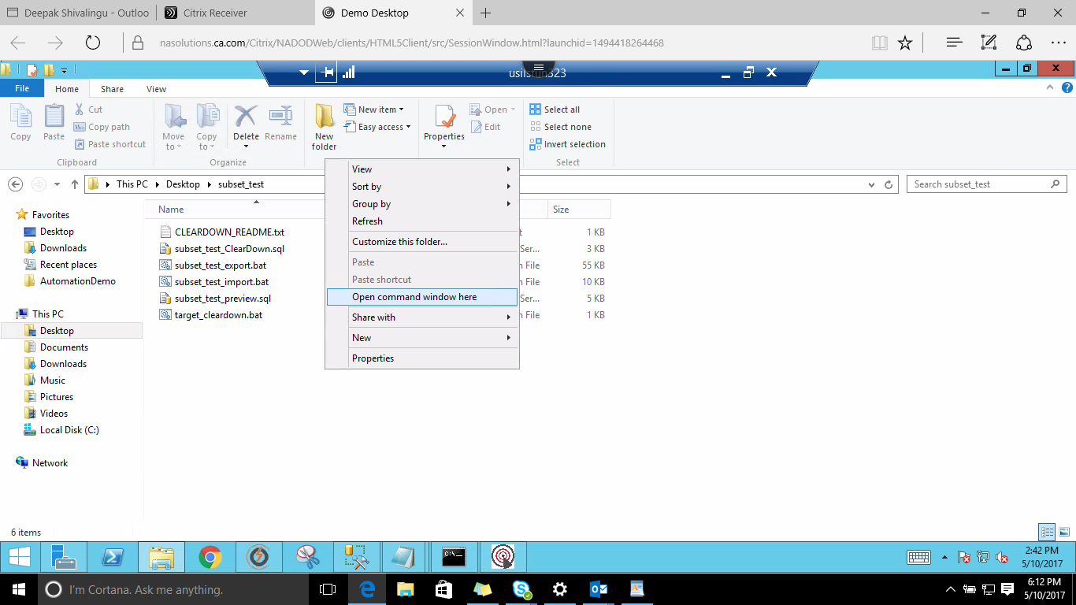

Execute the export.bat file by giving the username & password of the server and the server name as shown below:

Here the command executed is subset_test_export.bat

(sa/Gridt00ls with server name as: ANNACZ\SQLEXPRESS2014)

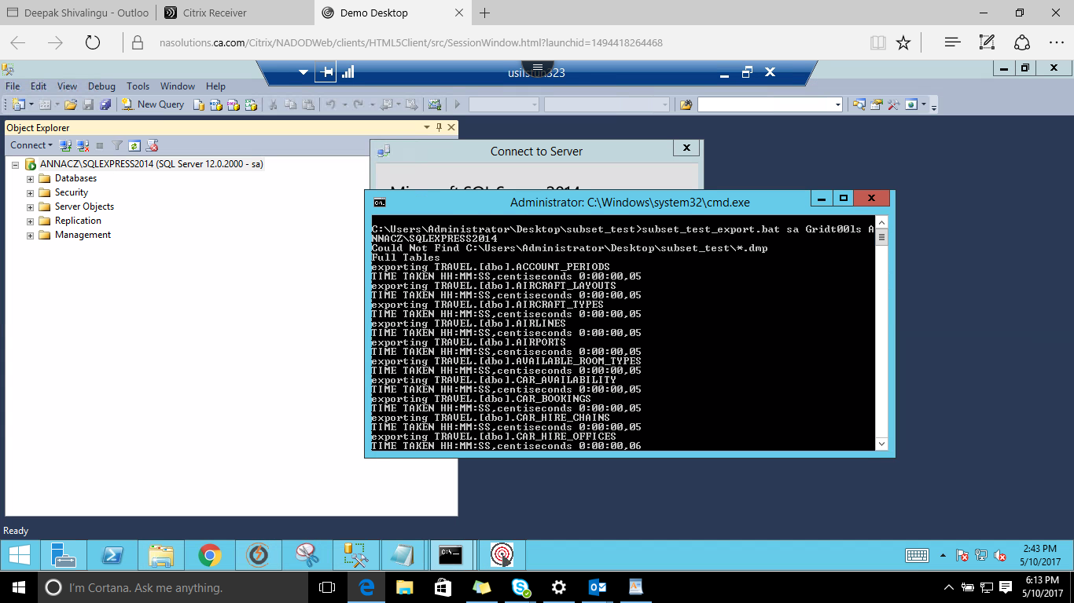

Once the command is executed, below screen displays

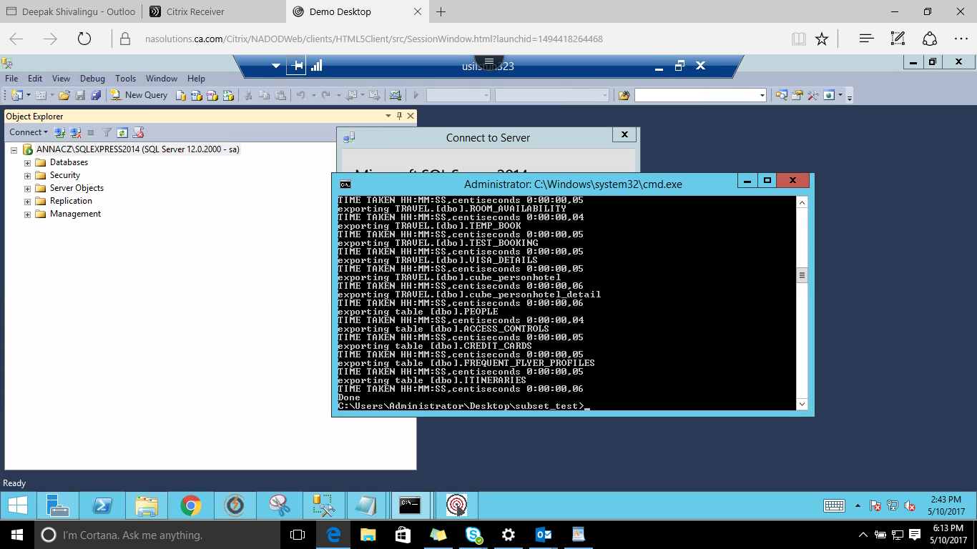

After exporting we have to import the Files to the Target**,** this is done by executing the import.bat file as shown below:

Here the command executed is subset_test_import.bat (id: sa/Gridt00ls and Server name as: ANNACZ\SQLEXPRESS2014 TRAVEL_EX) where TRAVEL_EX is the Target Name

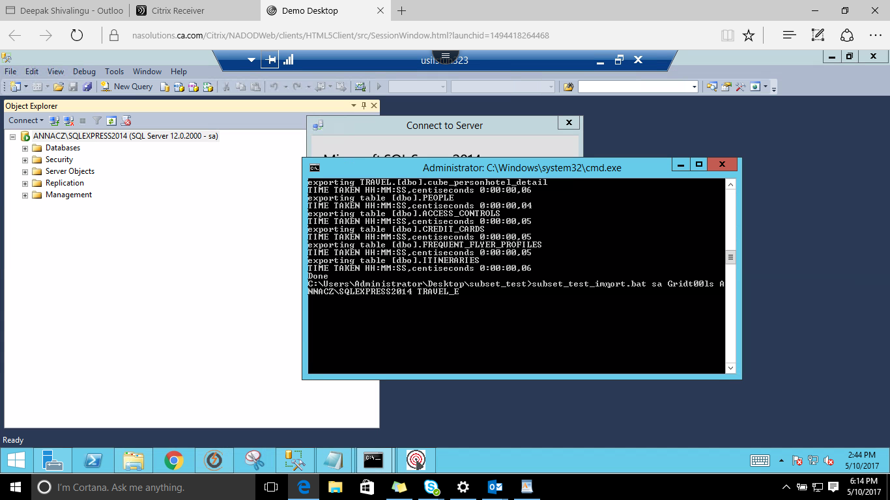

After Executing, the rows will be imported

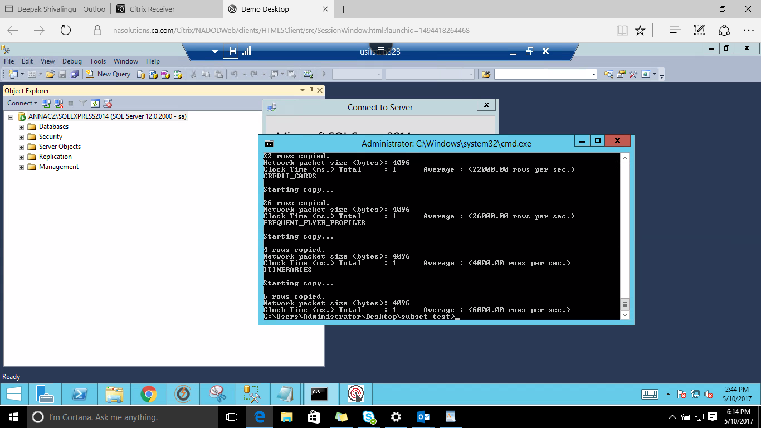

Navigate to Data Subset and Click on the Preview SQL button and click on RUN

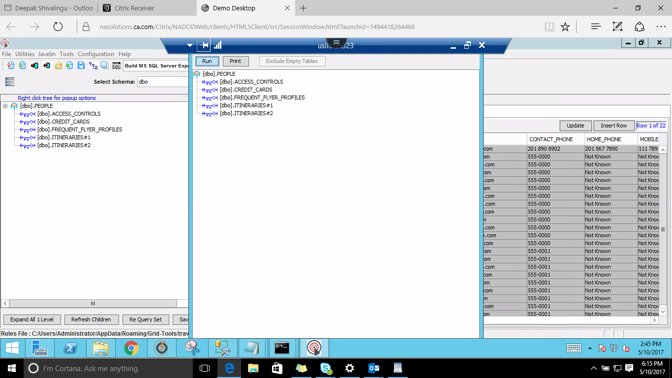

The Number of Rows which are imported will be displayed

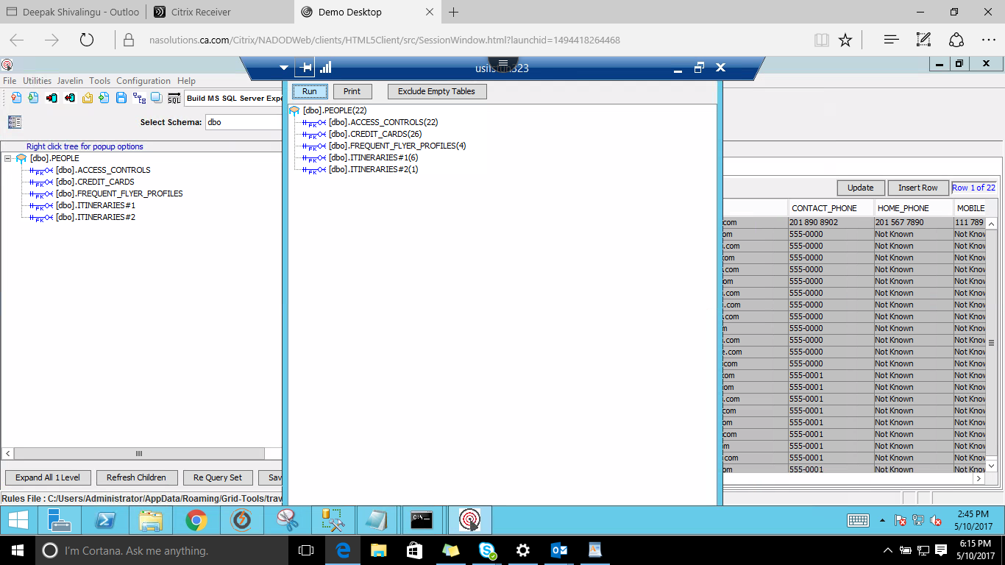

From the Tables run a SQL query to fetch the rows

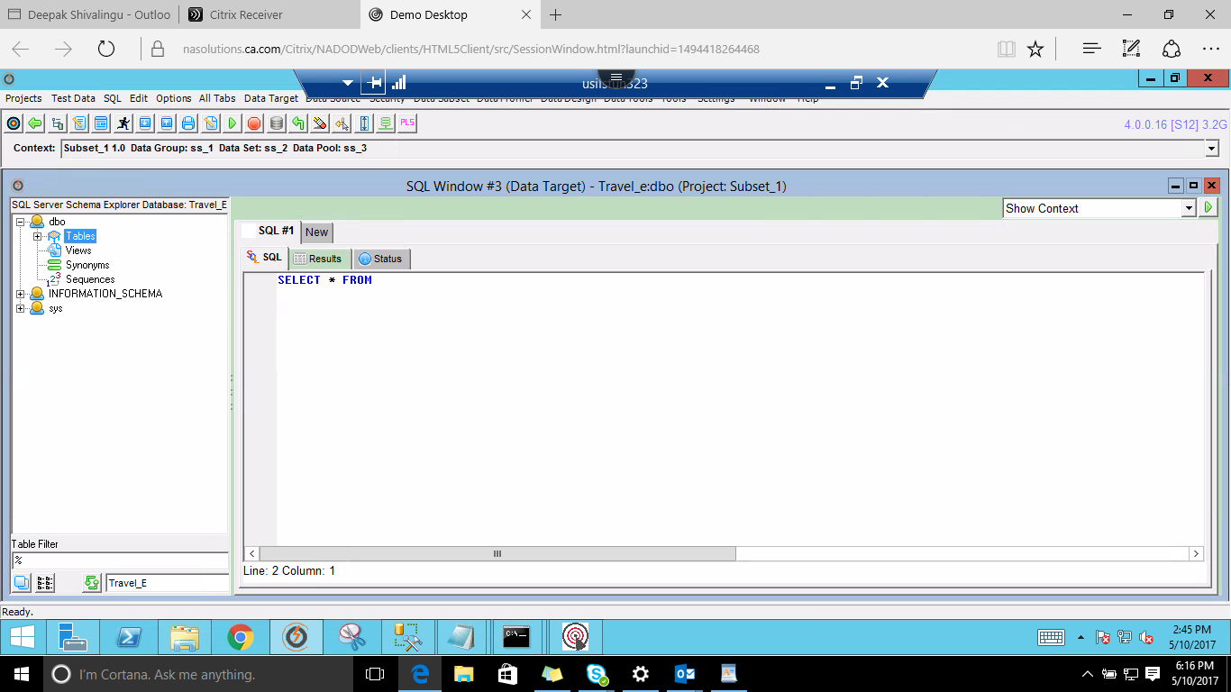

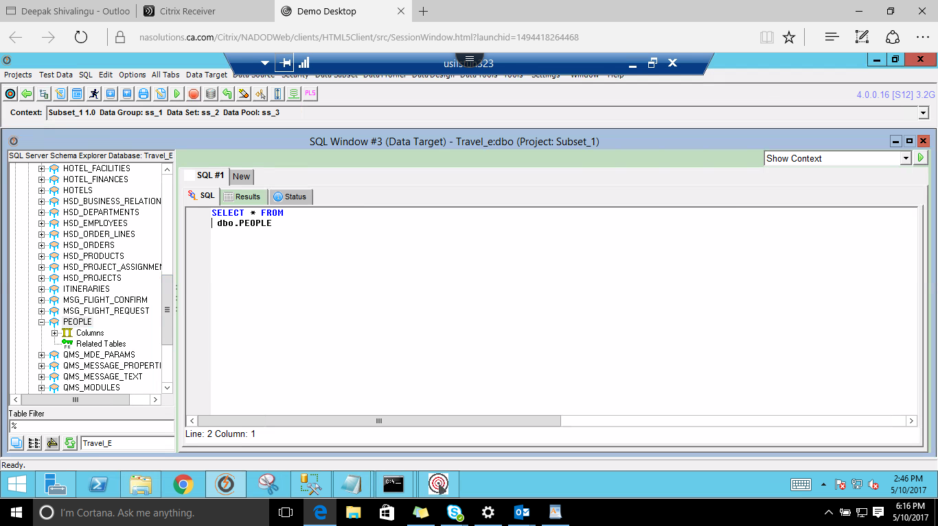

The number of rows fetched are shown as below

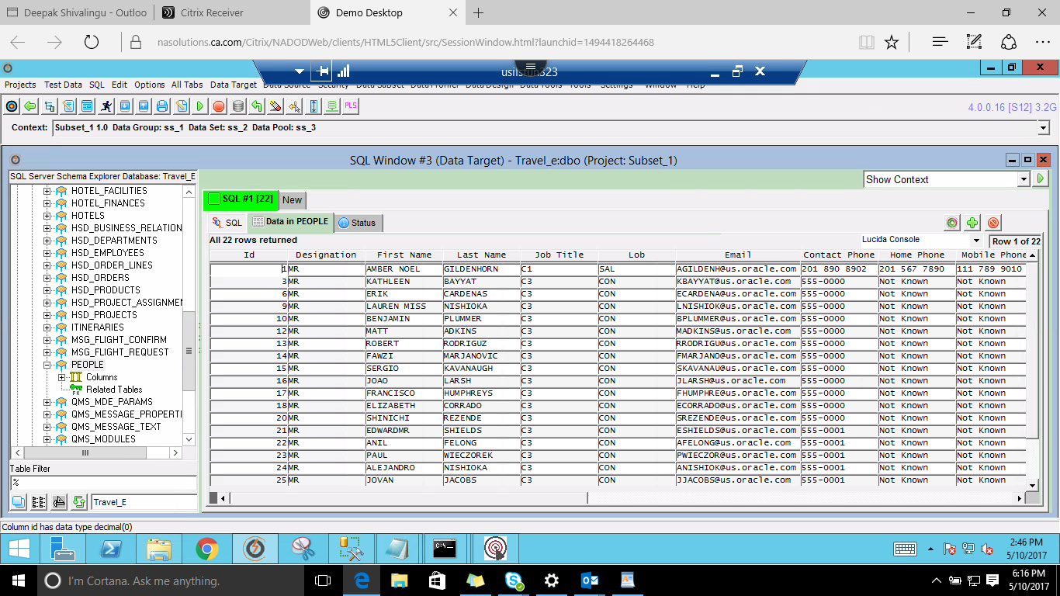

1. **Data Masking**

Secure millions of rows of data in minutes using automated data profiling and high performance masking engines. Masking of confidential data will be done here. **FASTDATA Masker** App is used for Masking.

Launch **FastDataMasker** 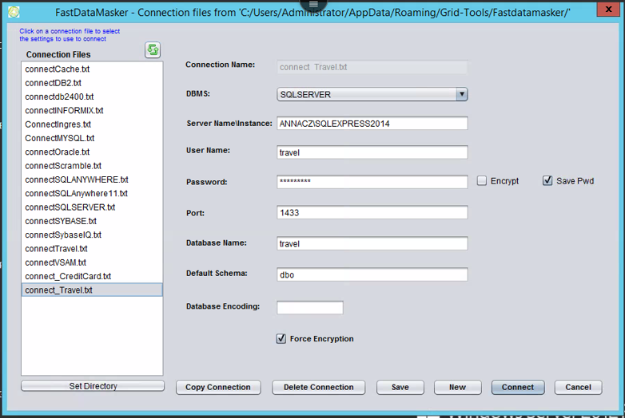

Click New button to create new connection by providing below details or select already existing connection to login. Uncheck Encrypt check box



Select a Table from Available Tables list and add to Masked Tables list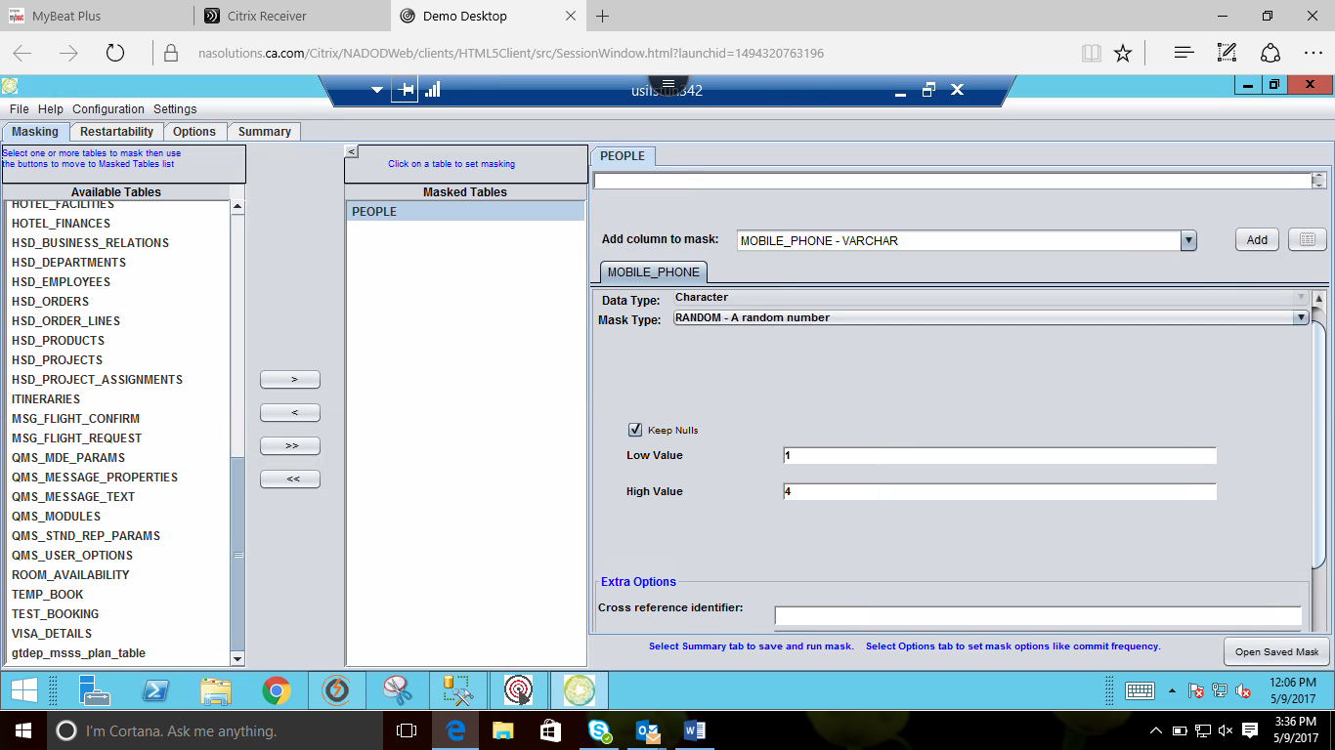

Select Column name from **Add Column Name to mask** drop down list and click Add button

Select corresponding Mask Type



Navigate to **Options** tab and add values in the below respective rows

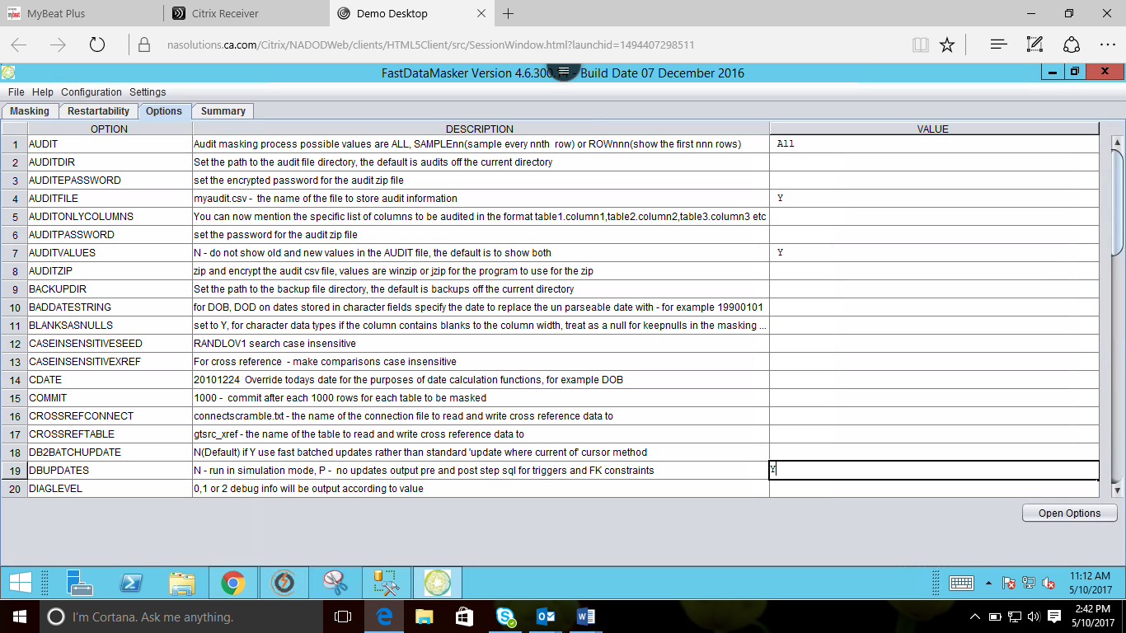

Navigate to **Summary** Tab and click on Save & Run Mask button

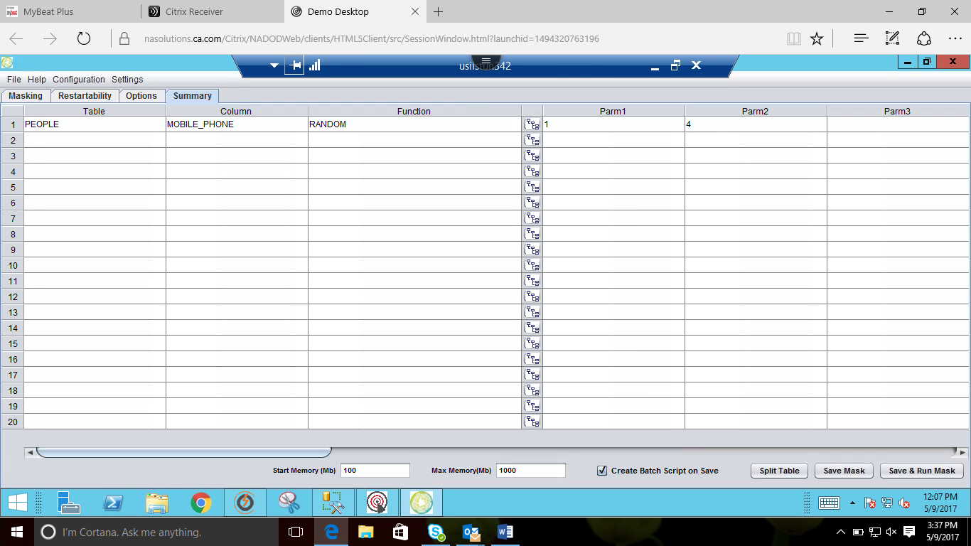

Specify the file name and Save the file

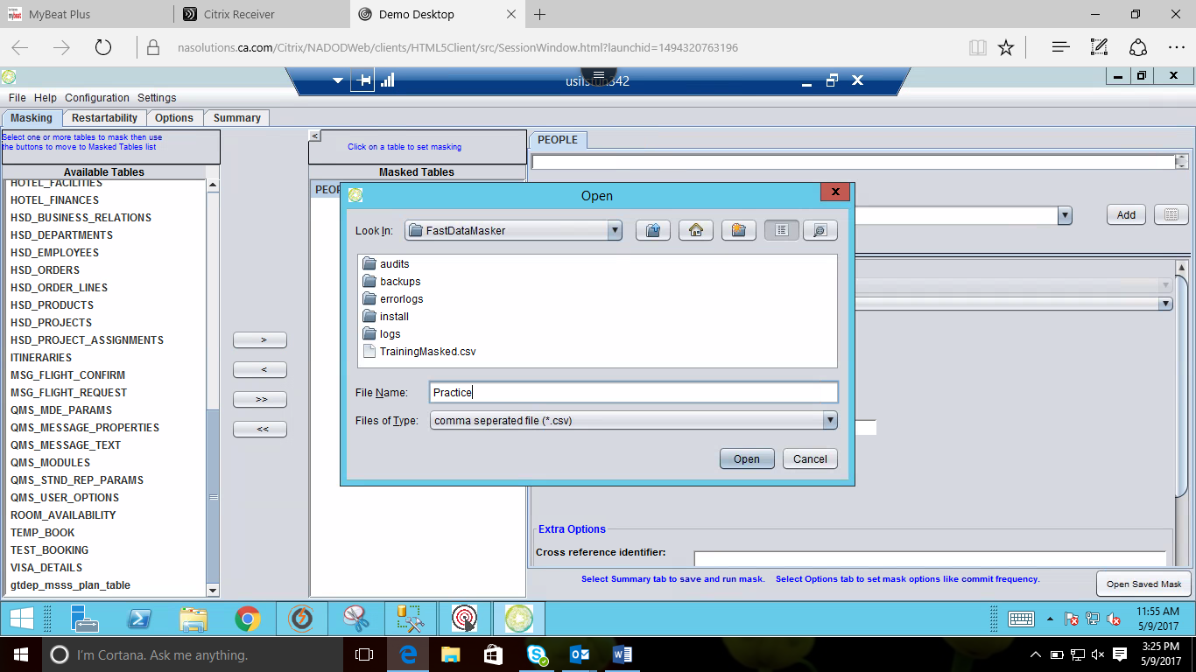

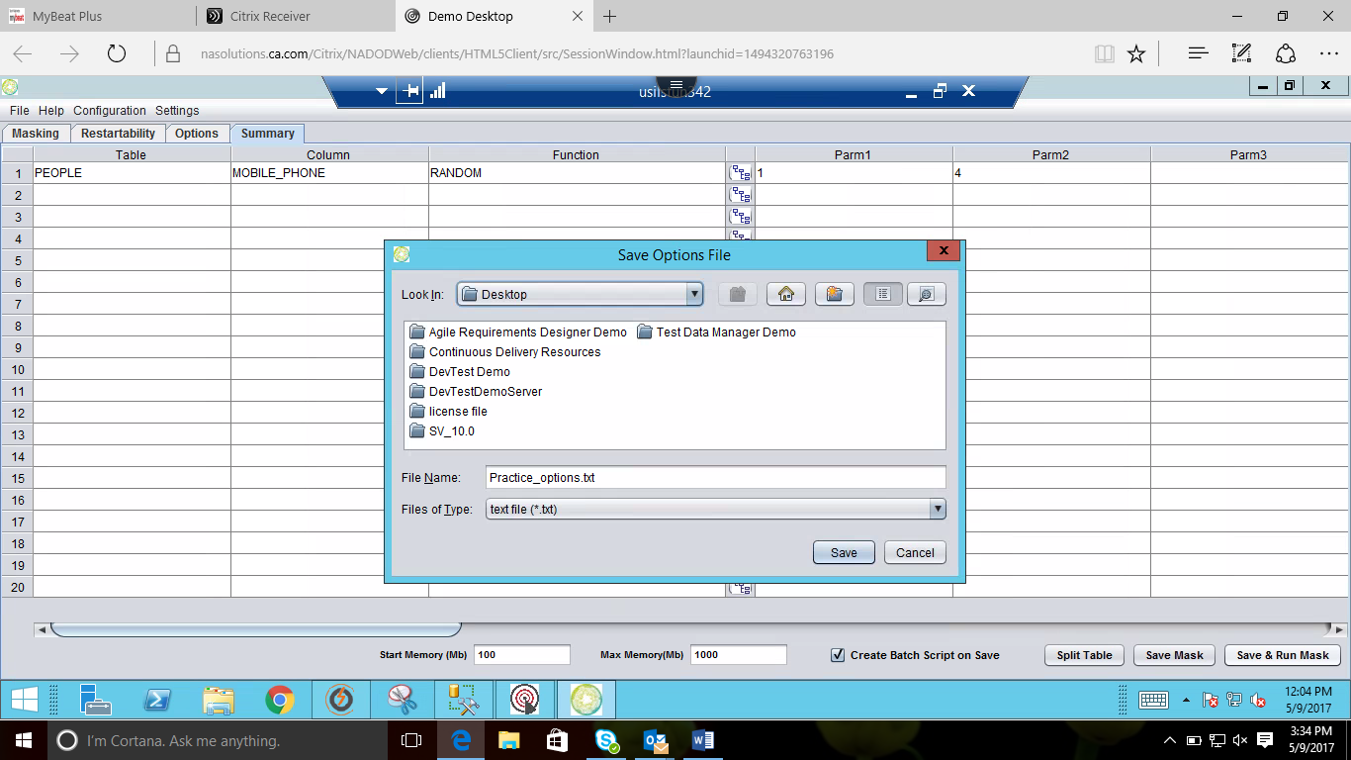

Masked file saved in selected file location

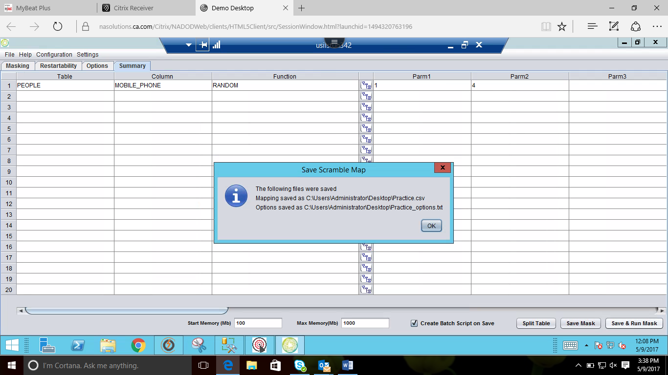

Masking completed message box

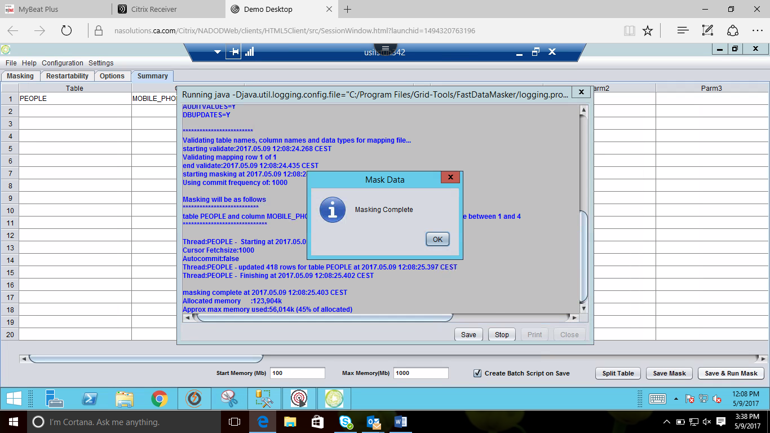

To view the masked file, navigate to following path: **C://user/administrator/appdata/roaming/gridtools/fastdatamasker/audits/(choose the file that is masked)** or Just **click windows -> All program -> %AppData%**

1. **Synthetic Data Generation**

Creates rich synthetic data which covers 100% of possible tests. It creates large volumes of data for performance and load tests. Also It Improve the efficiency of your testing. **Datamaker** App is used.

Navigate to Datamaker app

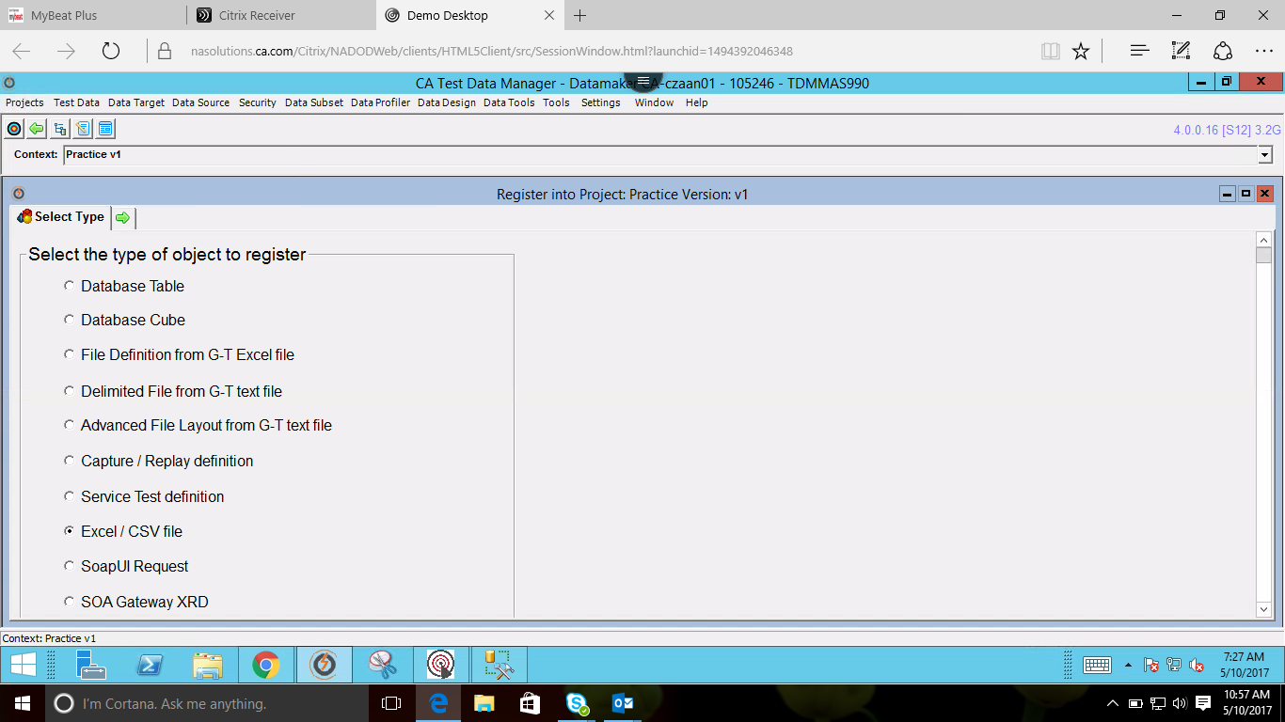

Select the project, click on version and create new data pool.

After creating data pool go to projects click on Register & select **Excel/CSV file**



Browse the excel file from the file location, check all the checkboxes then click on **Register / Import** button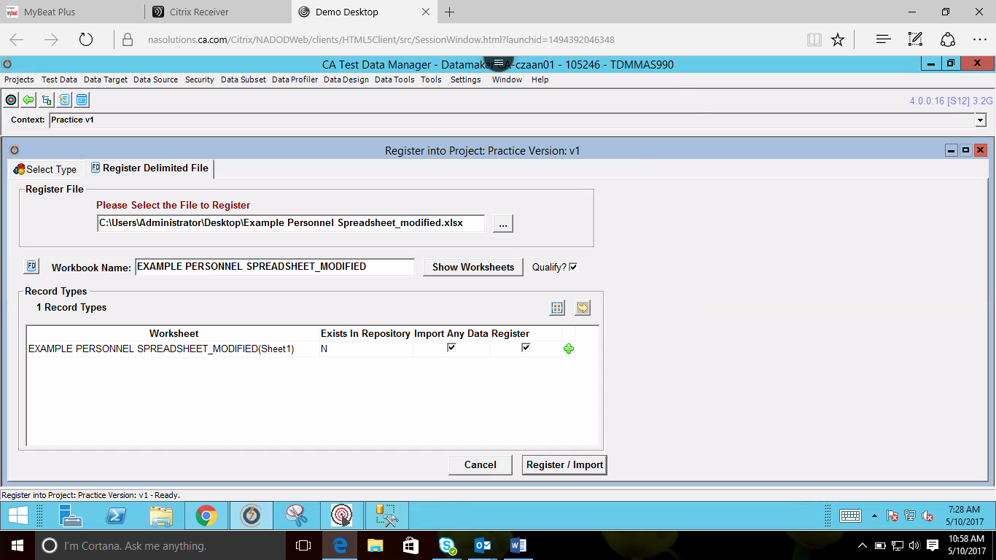

Registered & Imported

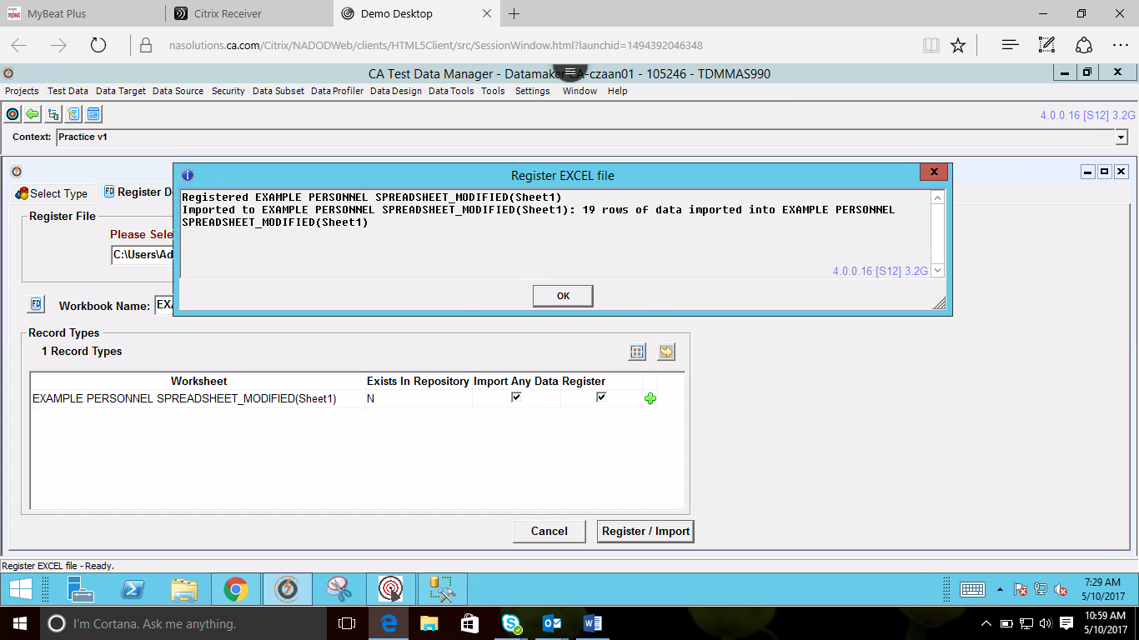

Select Projects > Actions for Registered Objects & then click on go to data pool and double click on excel file

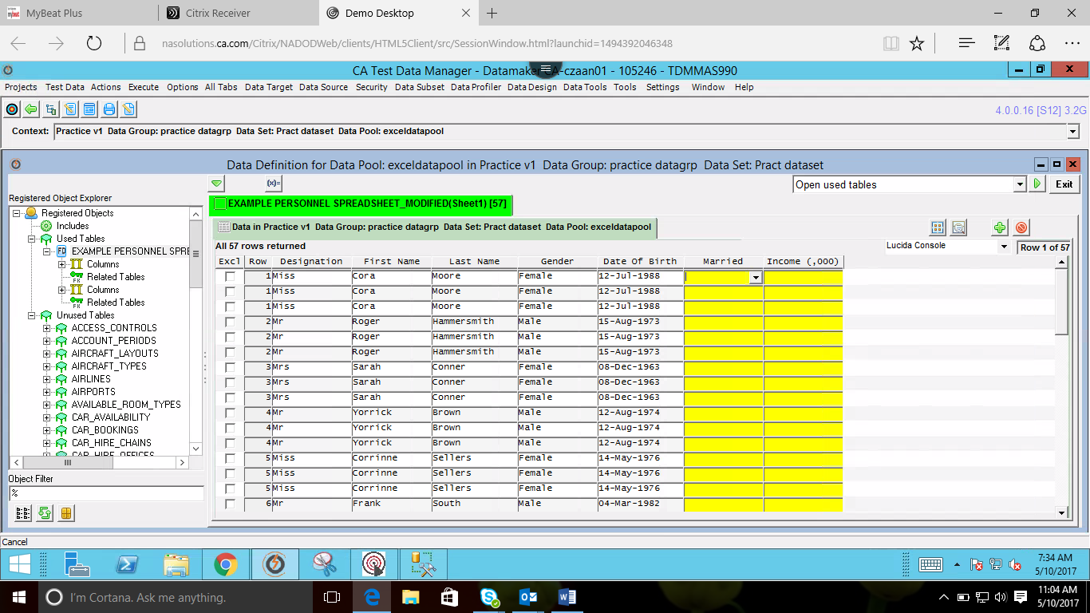

Double click on field select @randomseedname under listofvalues and then select required column need to be modified

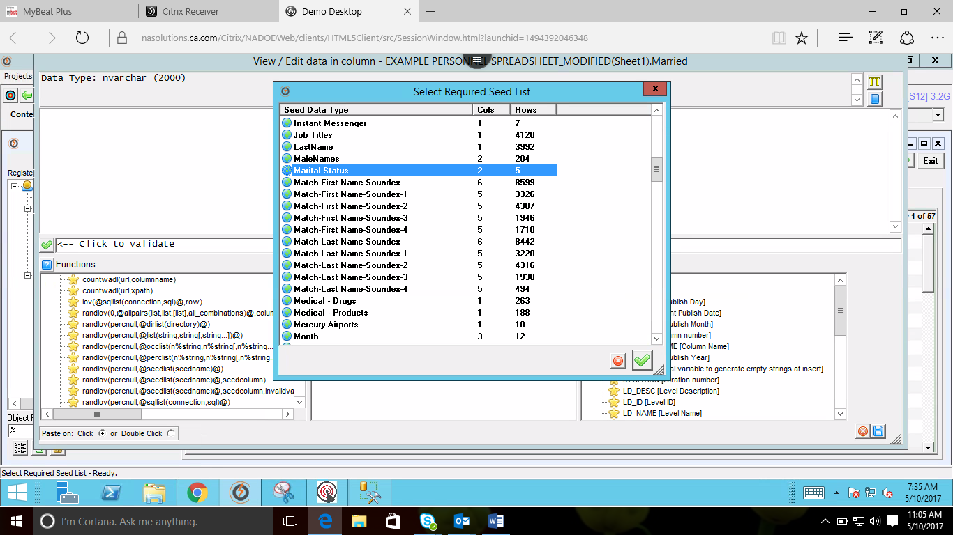

Percentile value should be set to 0

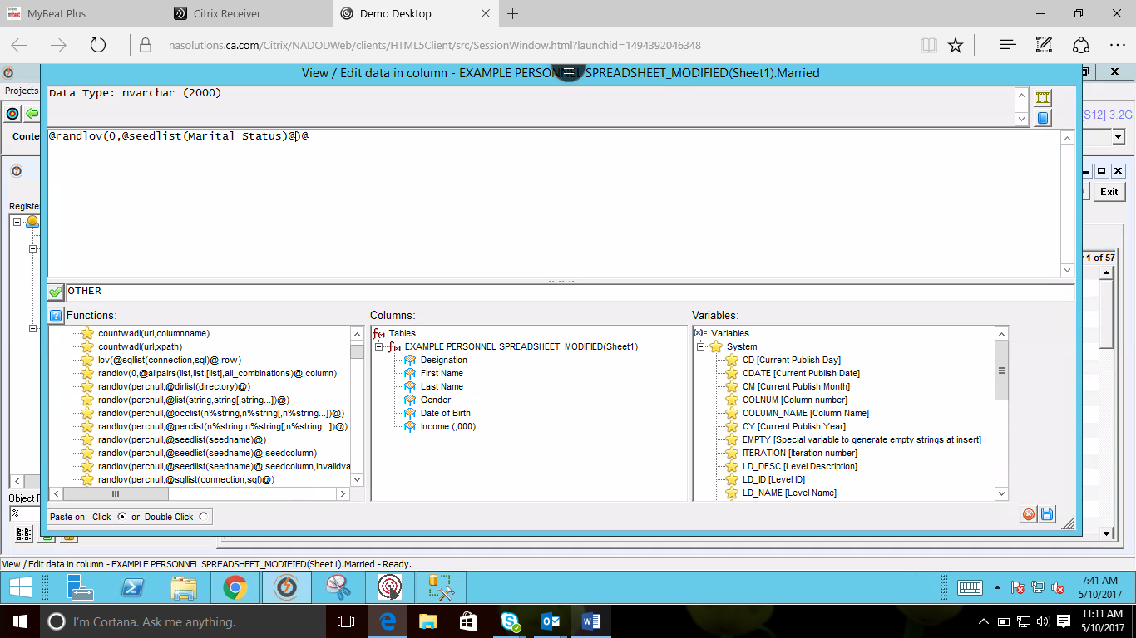

Similarly, for Salary select Numeric function and randomrange (min, max)

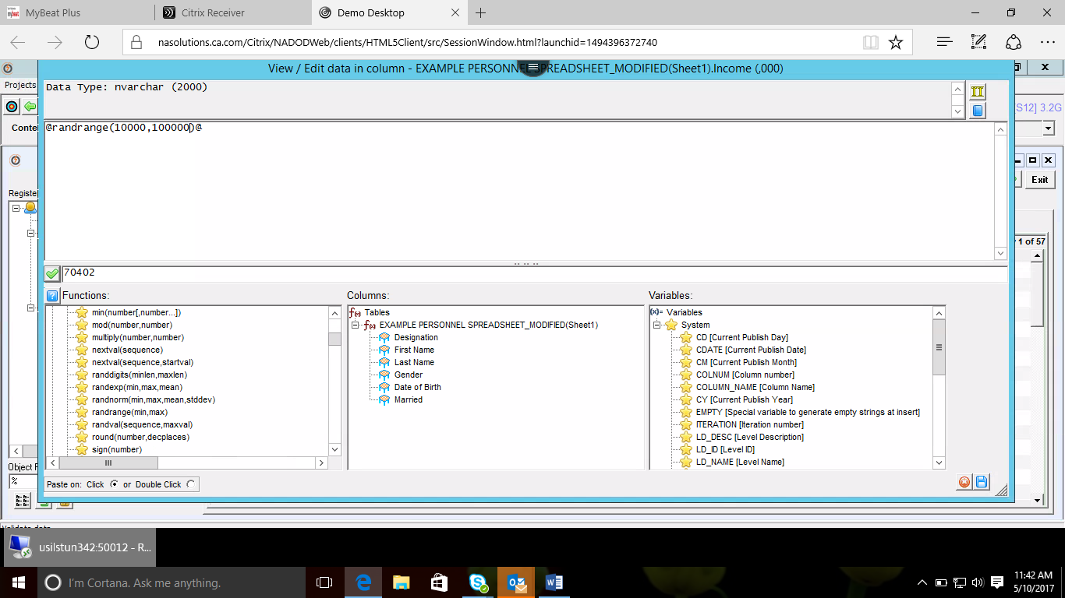

After validating the function, click on Preview icon from window

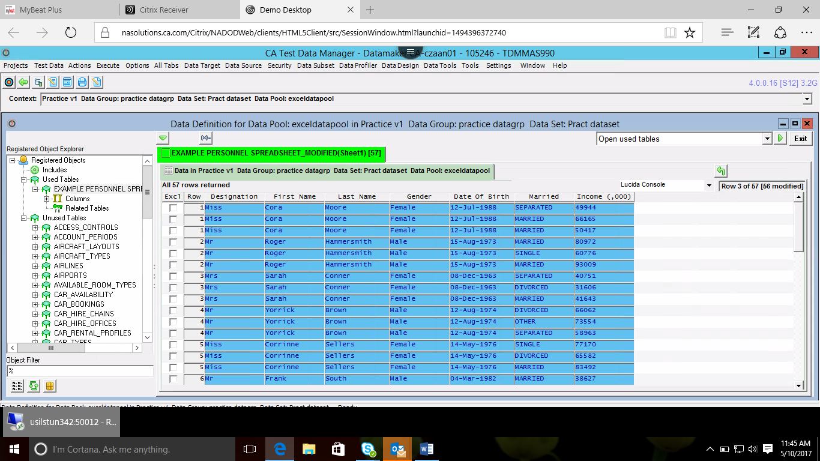

**Exporting data:**

Select **Publish to file** form the drop down list

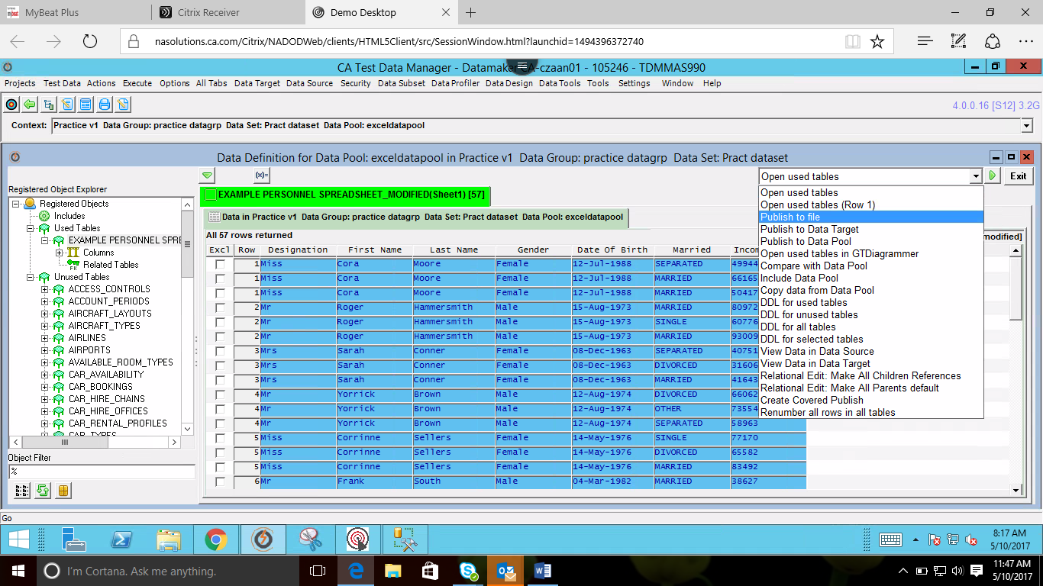

If required to generate more than 1 record enter the value in **Repeat** and select **Publish to file** from dropdown list and run

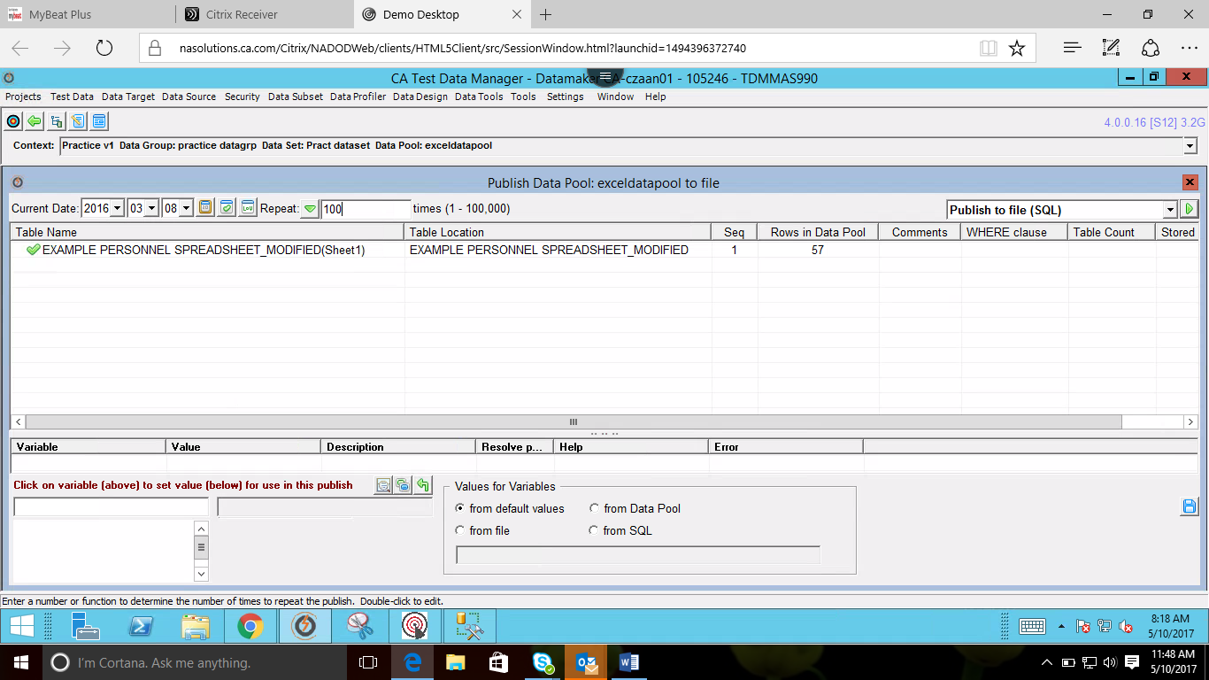

Select appropriately and run

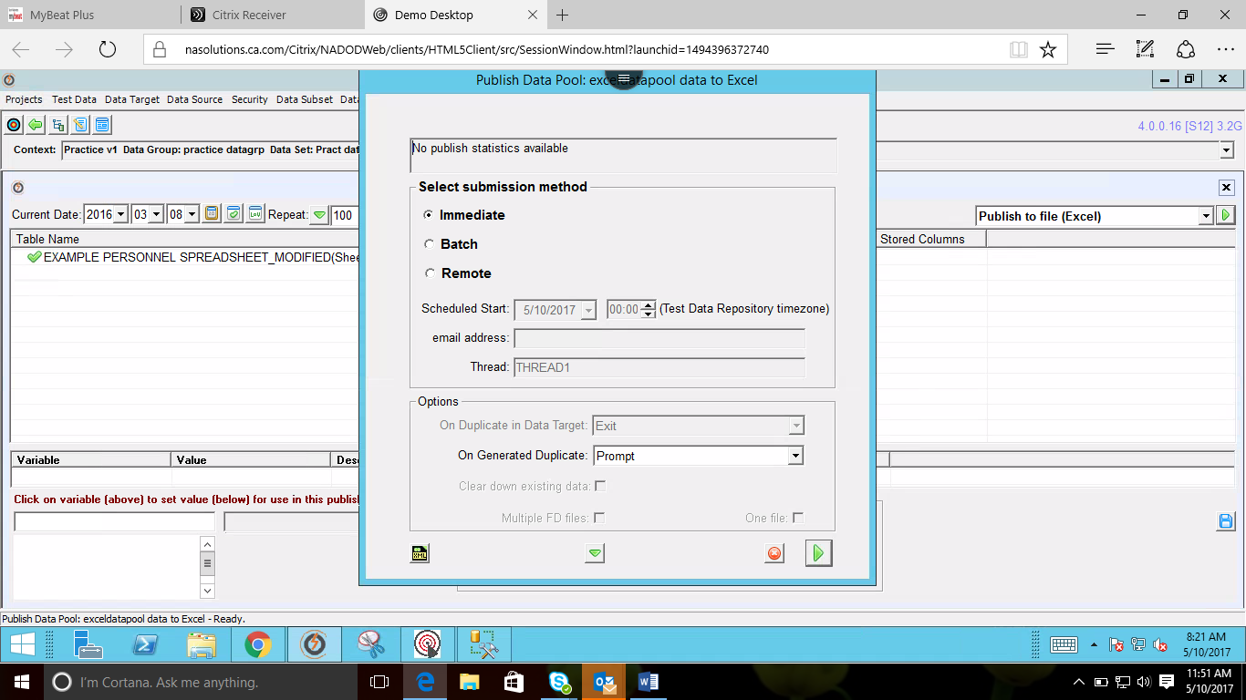

Choose the folder and run

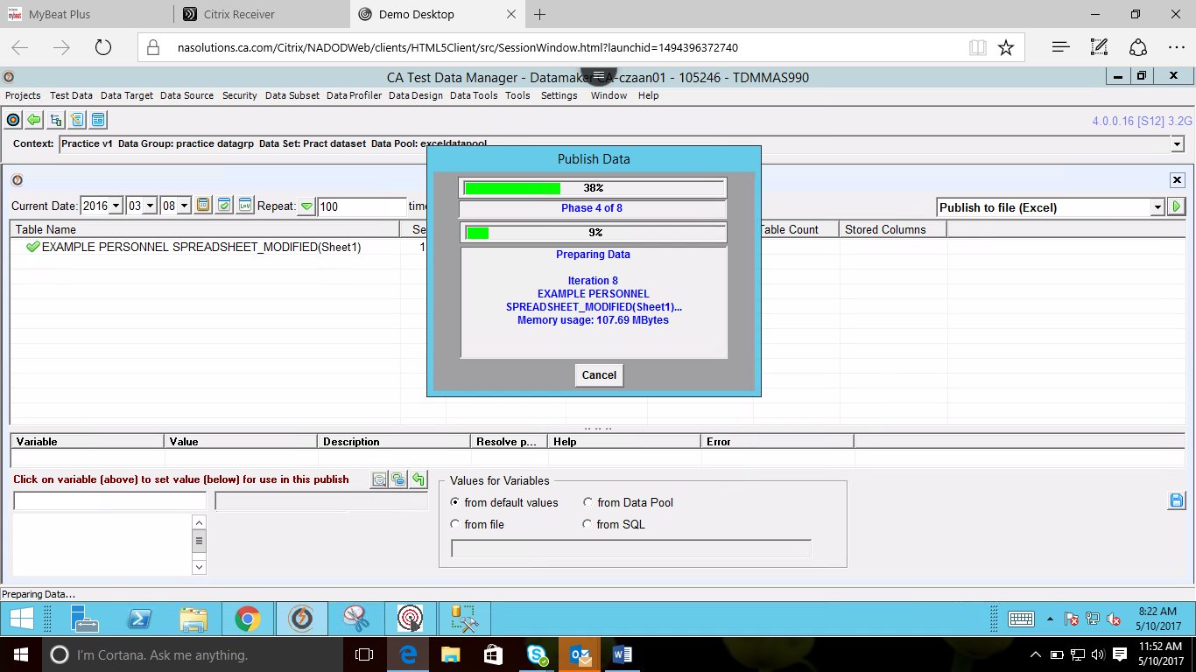

Published data

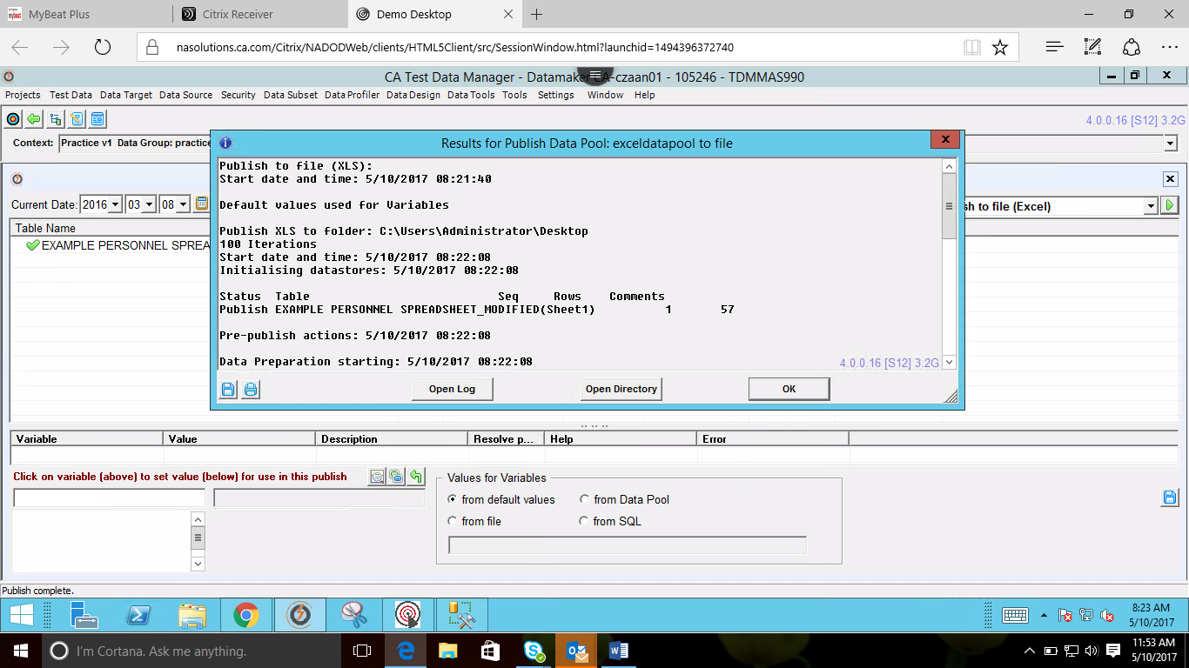

1. **Agile Requirements Designer**

CA Agile Requirements Designer is an end-to-end requirements gathering, test automation and test case design tool which drastically reduces manual testing effort and enables organizations to deliver quality software to market earlier and at less cost

Home page

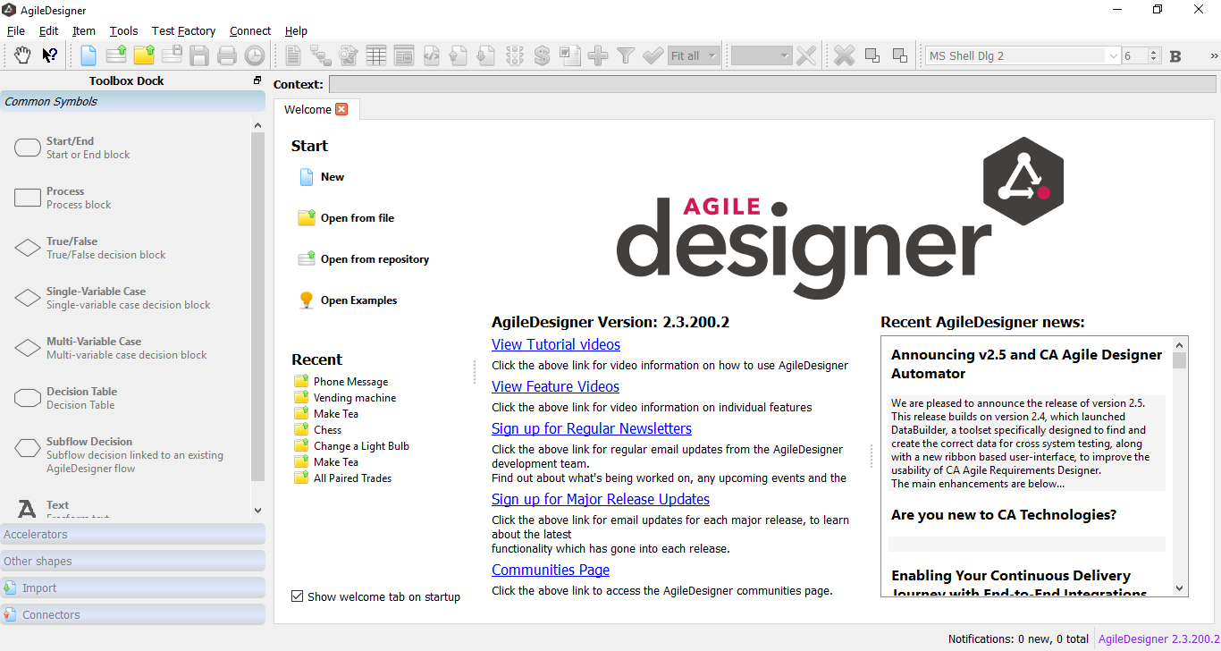

Fill these properties and click Next

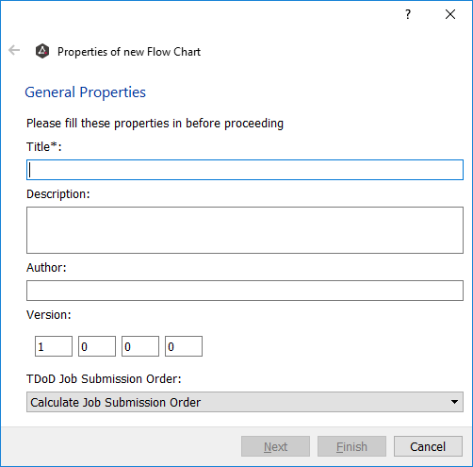

Fill Flow Chart Details as well

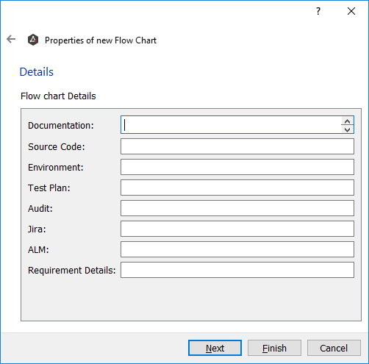

New Visual Flow created

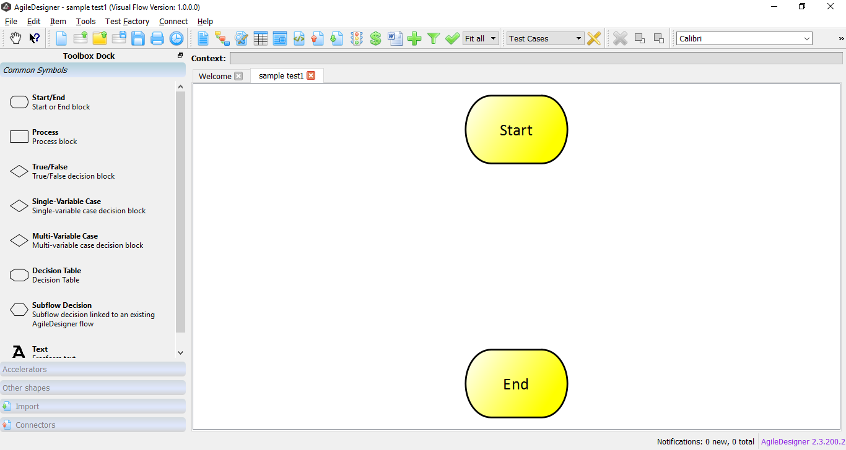

Select necessary flowchart symbols accordingly from ToolBox dock

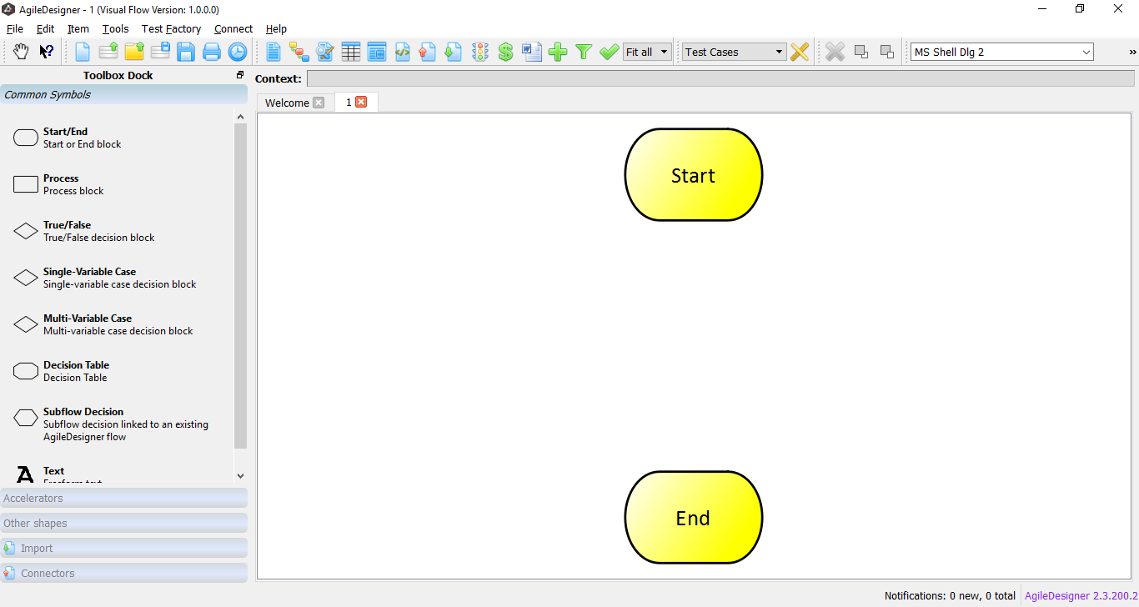

Sample Workflow:

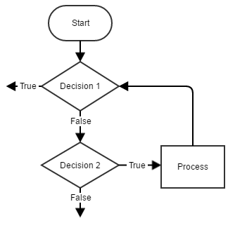

1. **Useful Links**

Make sure to register in Partner Portal in [www.ca.com](http://www.ca.com) to get to know about trainings, demos and updates on TDM

* **TDM:**
  + [**https://docops.ca.com/ca-test-data-manager/3-6/en/getting-started**](https://docops.ca.com/ca-test-data-manager/3-6/en/getting-started)
  + [**https://docops.ca.com/ca-test-data-manager/4-1/en**](https://docops.ca.com/ca-test-data-manager/4-1/en)
* **TDM Demo Guide:**
  + **file:///D:/Sathya/TDM/TDM_DoD_Demo_Guide.pdf**
  + 
* **ARD:**
  + [**https://docops.ca.com/ca-agile-requirements-designer/2-1/en/getting-started**](https://docops.ca.com/ca-agile-requirements-designer/2-1/en/getting-started)
  + [**https://www.ca.com/content/dam/ca/us/files/data-sheet/ca-agile-requirements-designer.pdf**](https://www.ca.com/content/dam/ca/us/files/data-sheet/ca-agile-requirements-designer.pdf)